Week3 Lab

Terraform Introduction

-Pratham Sapra

### Step1,2&3 : Write the first configuration file with AWS provider, deploy Amazon EC2

* Change Cloud9 settings to see the hidden files

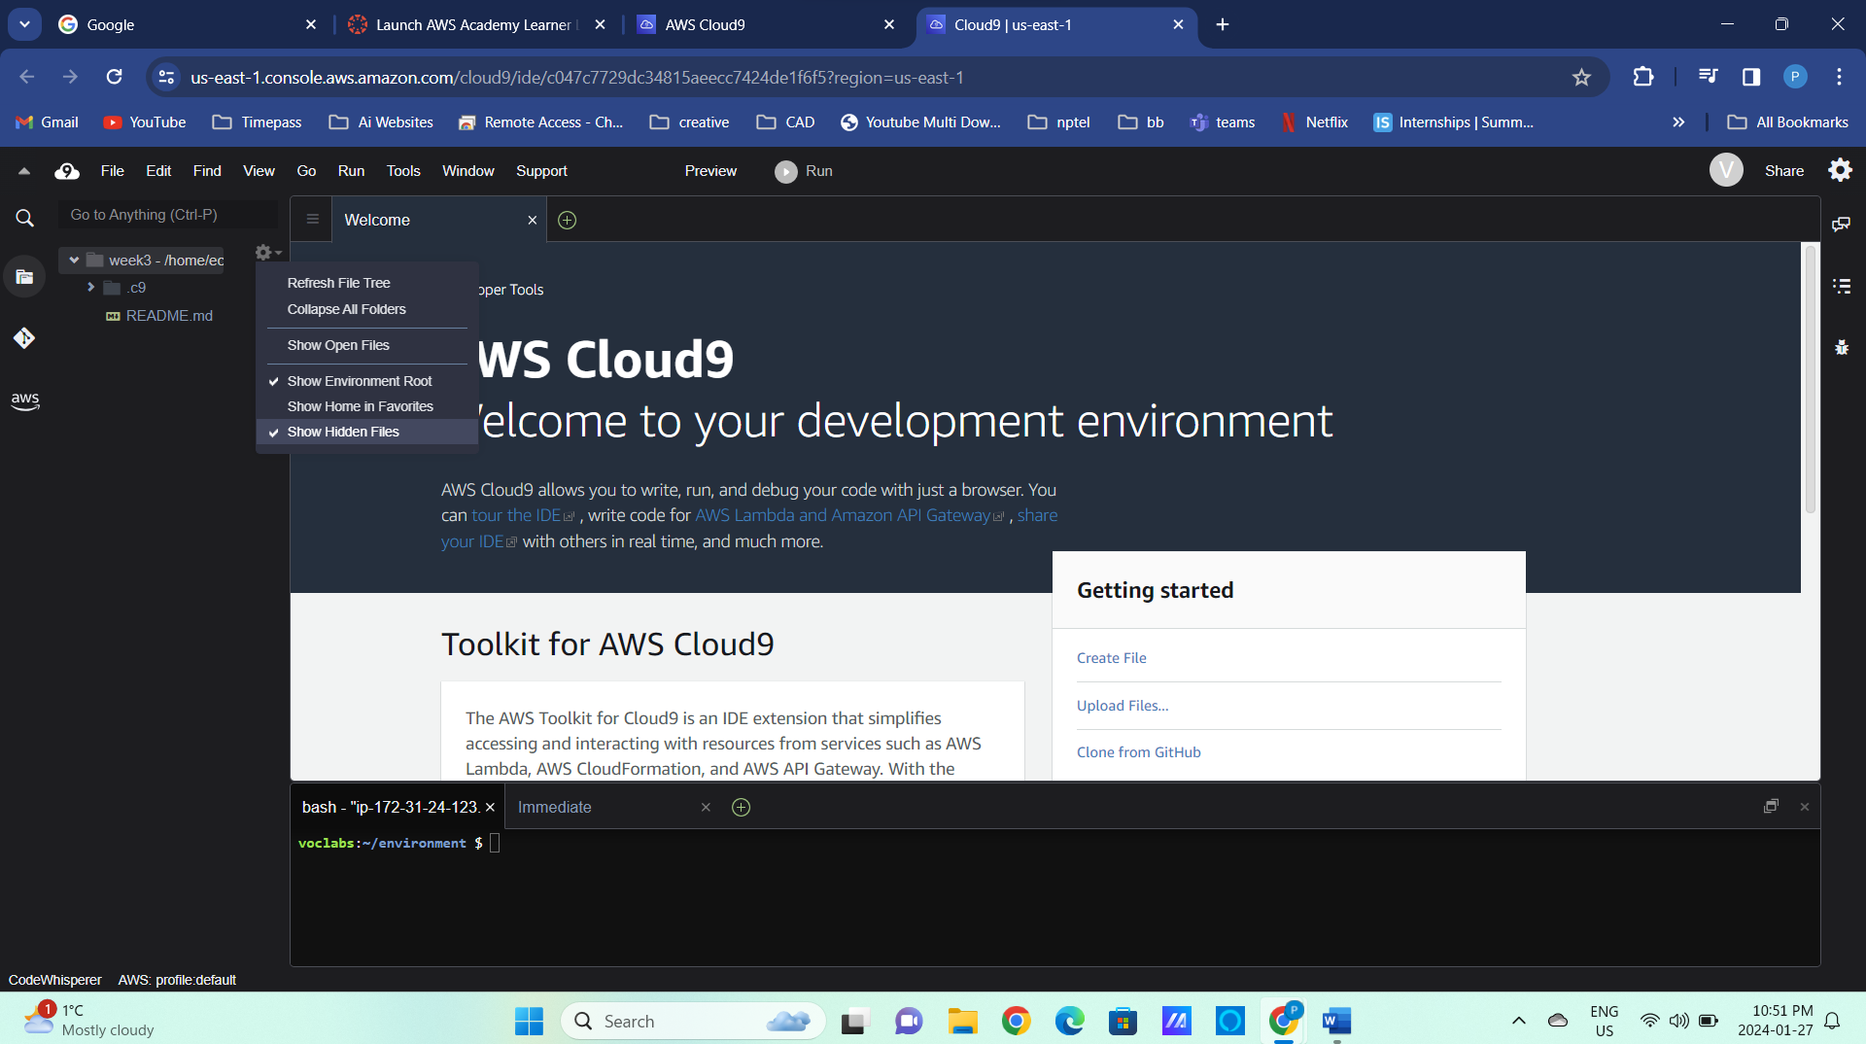

Add Session1 and Session 2 folder

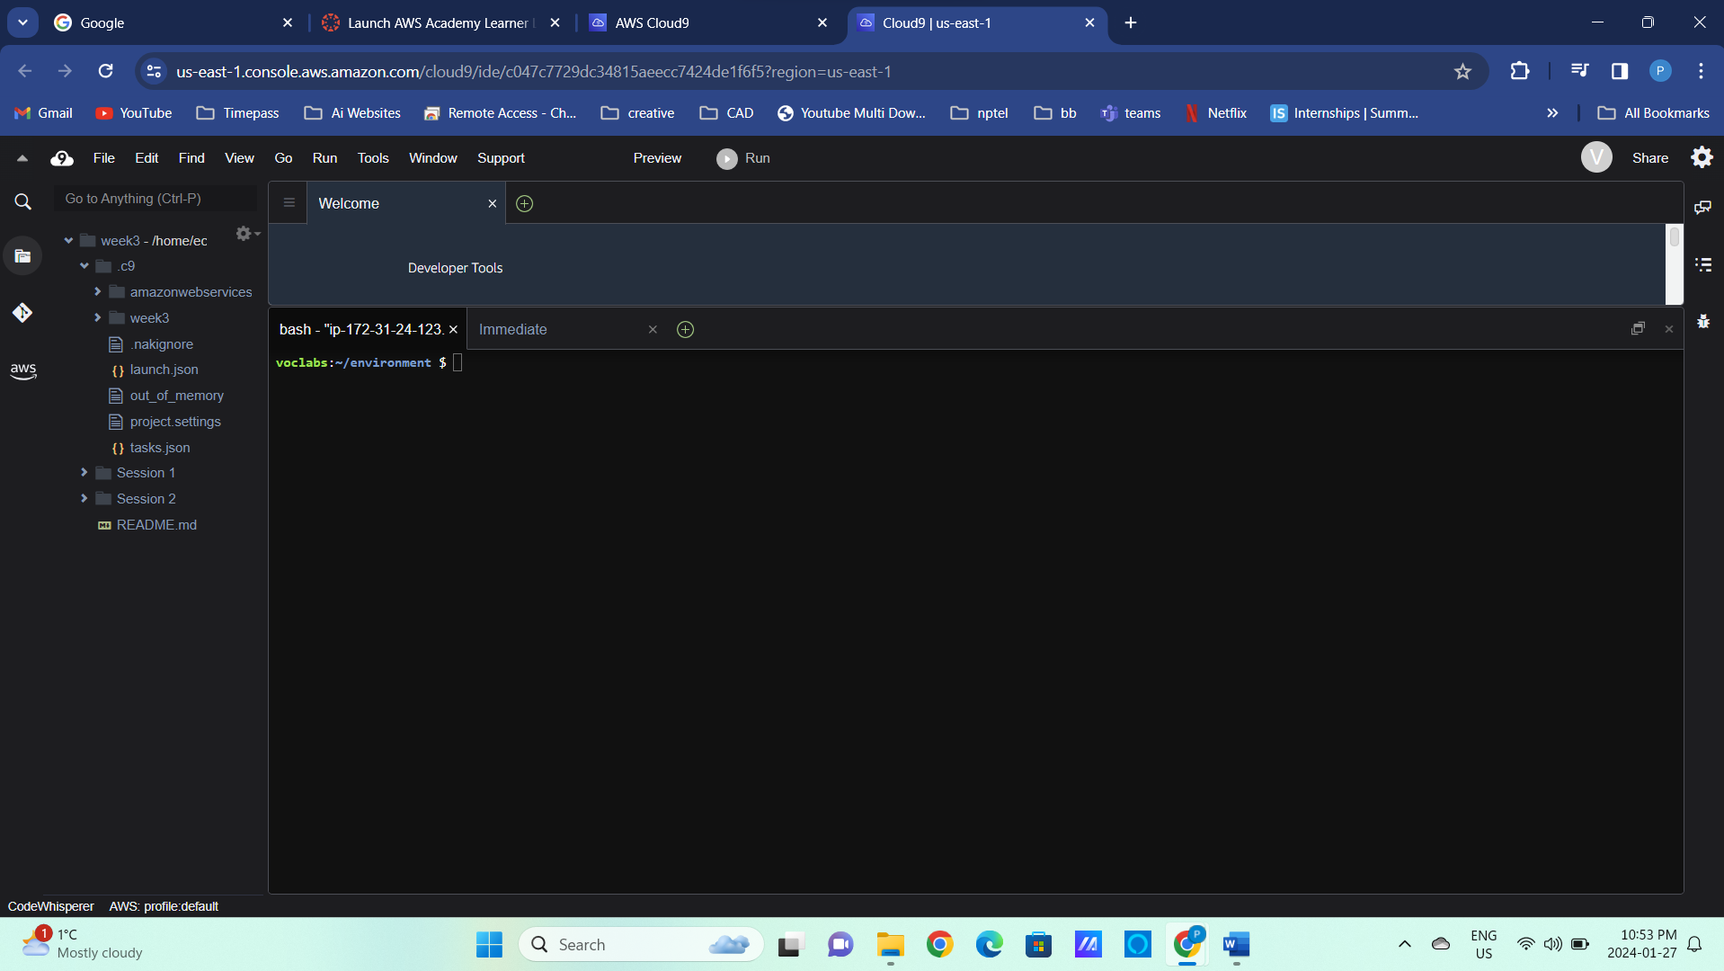

Install Terraform from the given link

<https://developer.hashicorp.com/terraform/tutorials/aws-get-started/install-cli>

or Use the code given below

sudo yum install -y yum-utils

sudo yum-config-manager --add-repo <https://rpm.releases.hashicorp.com/AmazonLinux/hashicorp.repo>

sudo yum -y install terraform

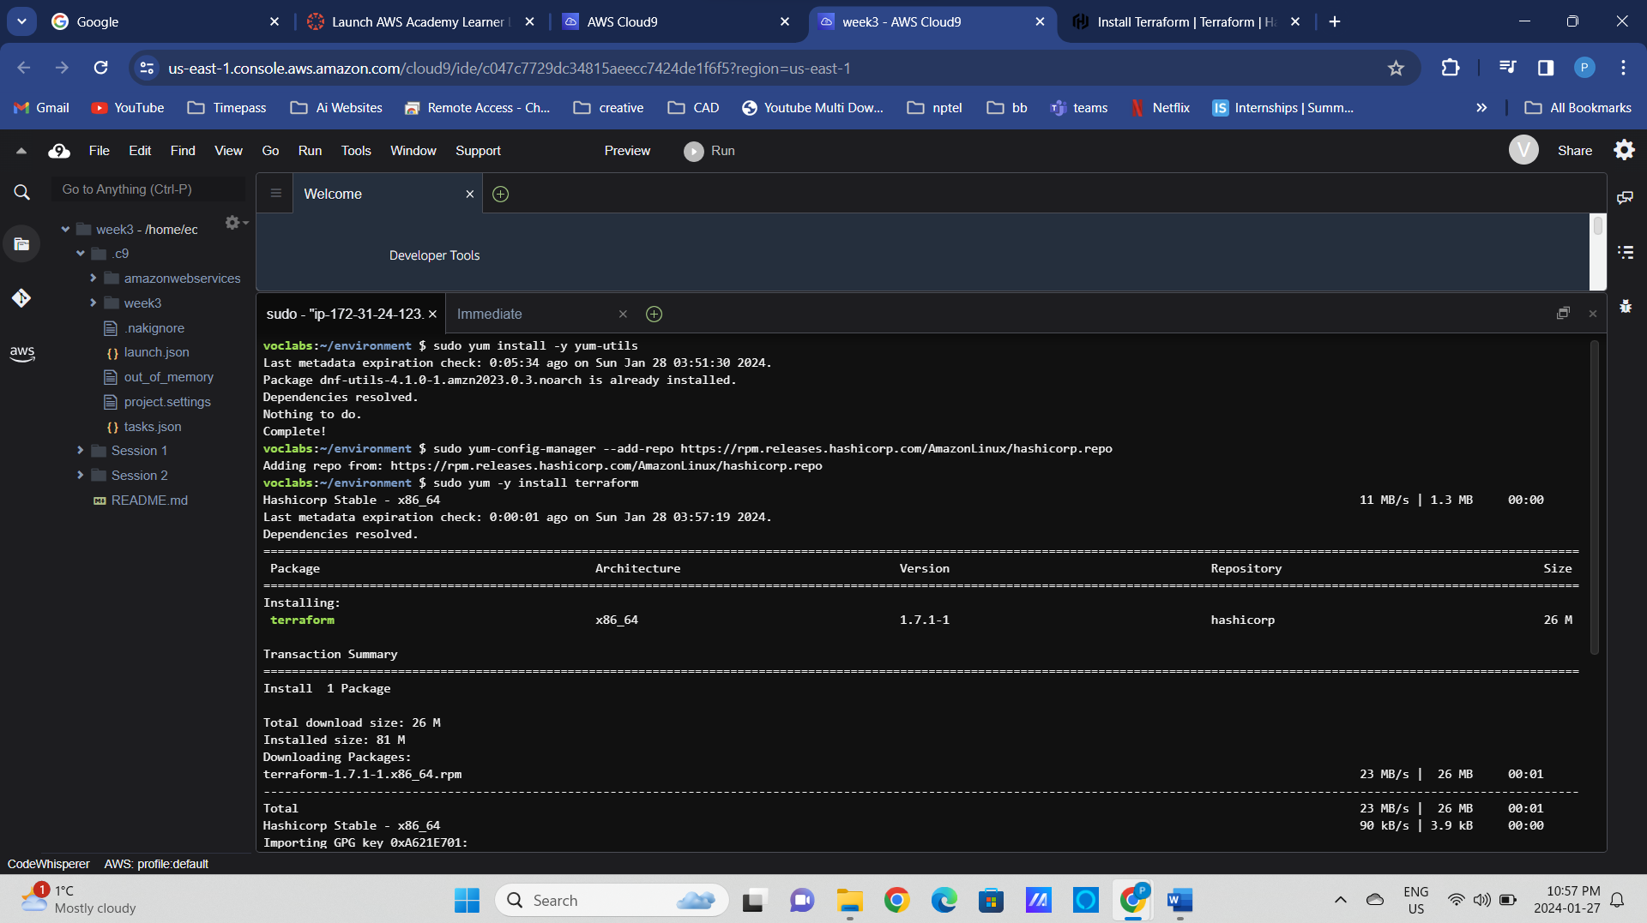

Open the terminal in the given folder

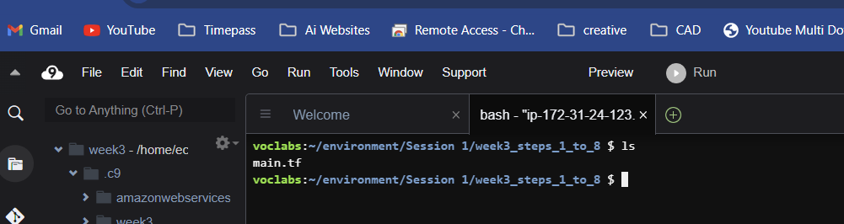

* Define the AWS provider and Amazon EC2, initialize the environment

terraform init # Initialize the Terraform environment

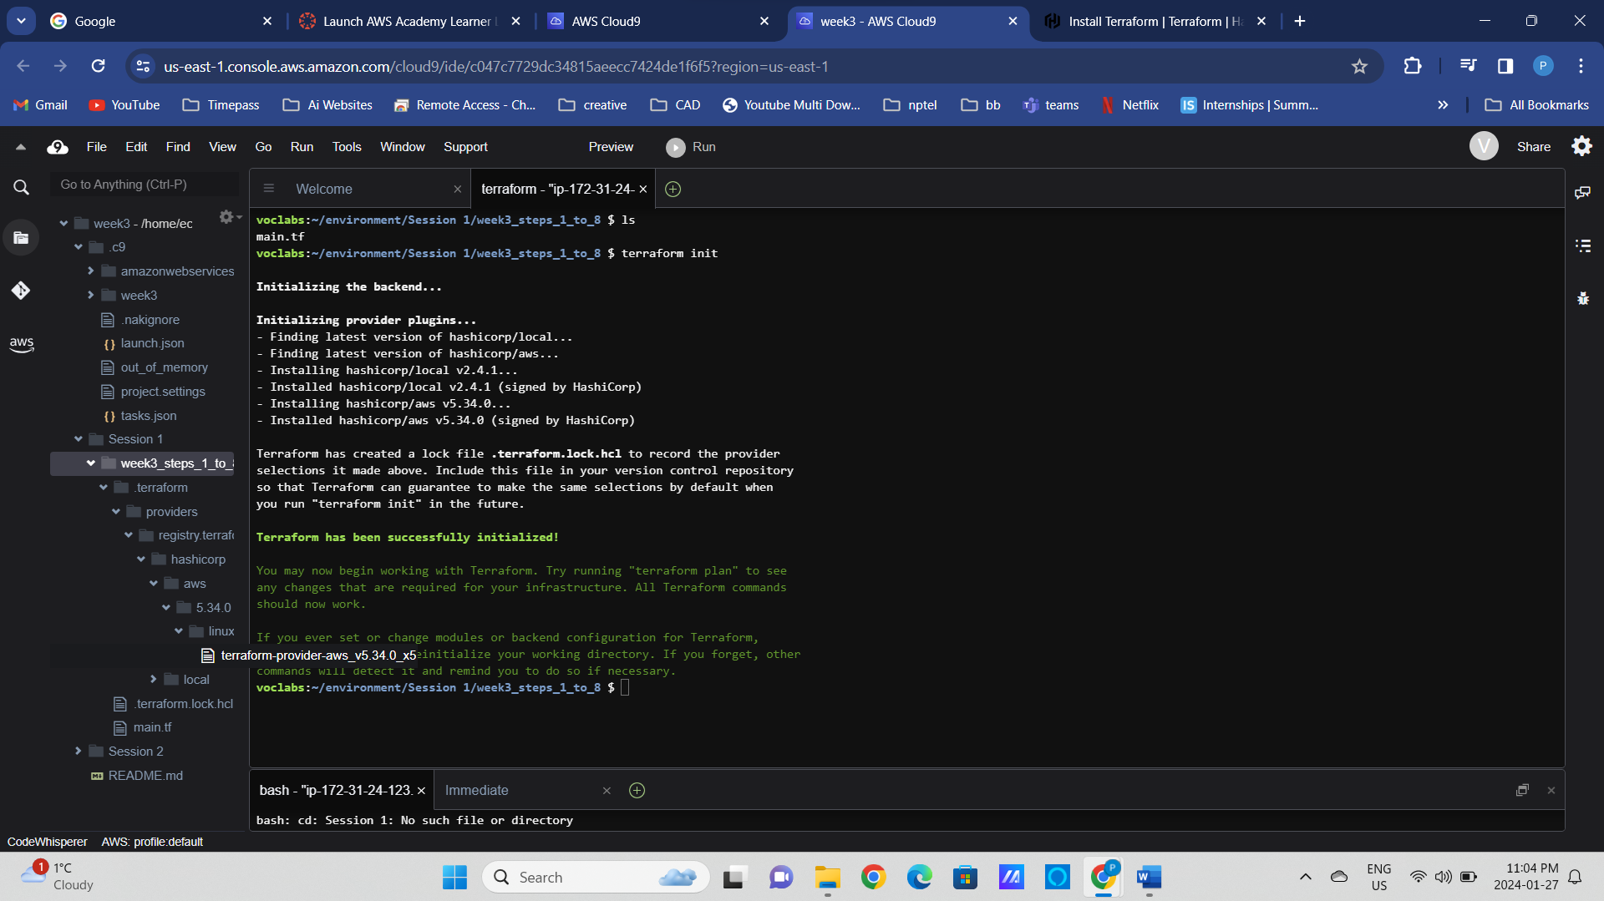

alias tf=terraform

tf fmt

tf validate

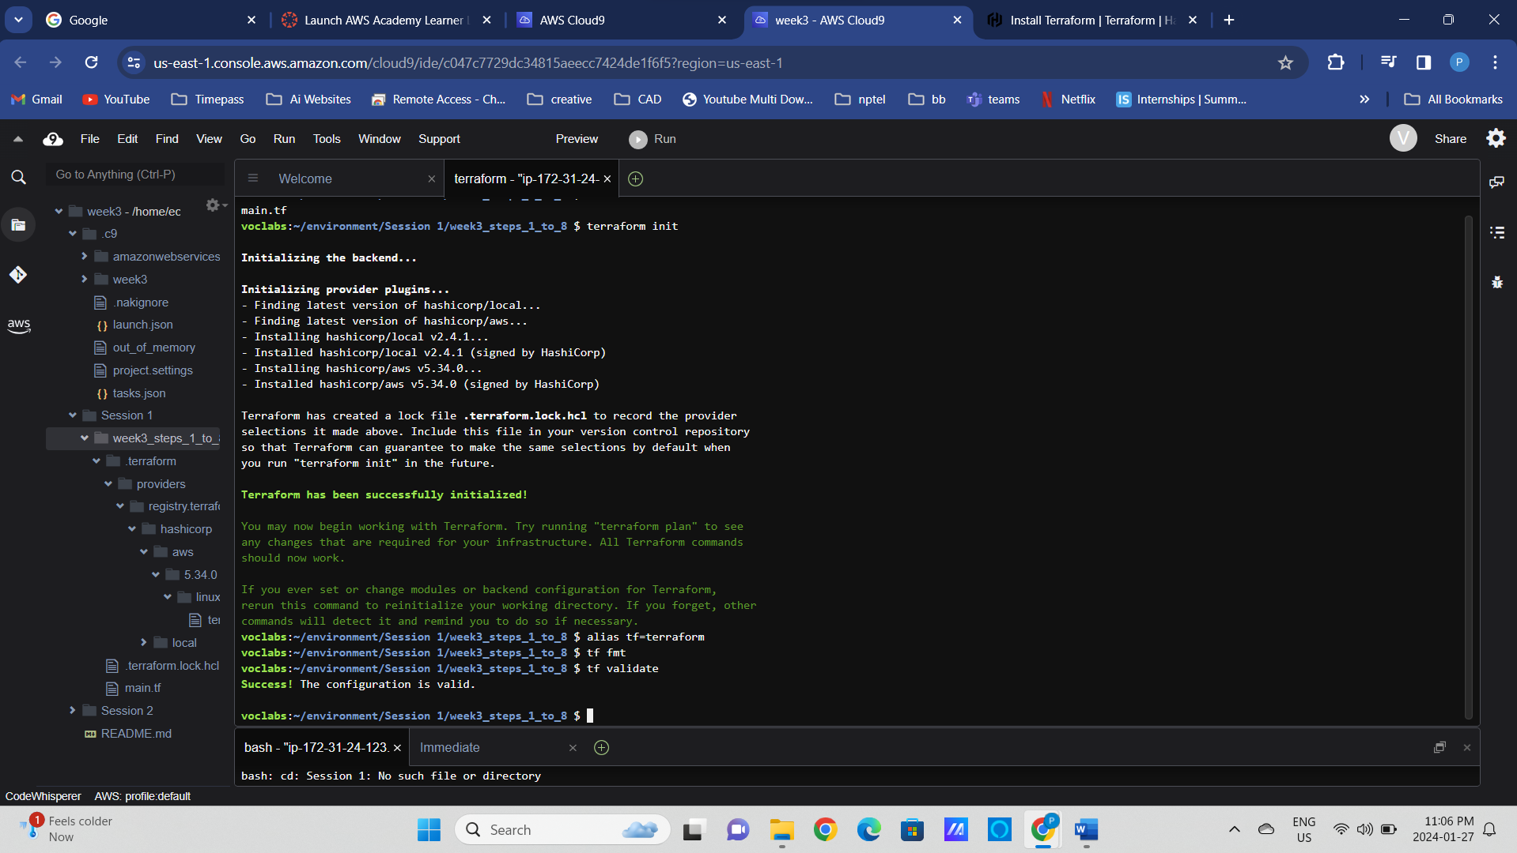

tf plan

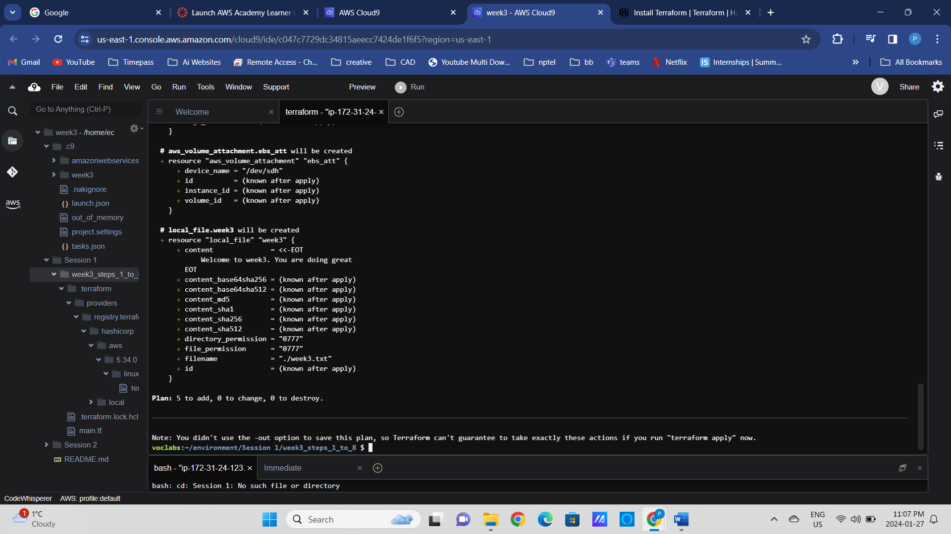

tf apply

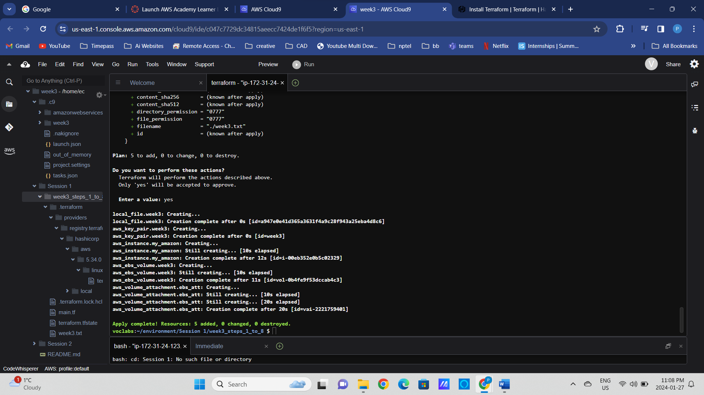

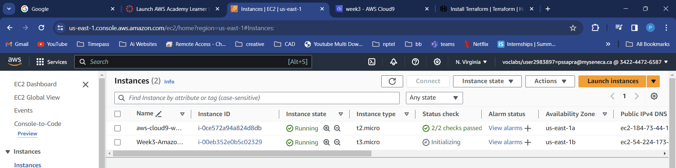

* Deploy EC2, verify that it has been deployed via aws cli and AWS management Console. Is this change disruptive?

terraform apply -destroy

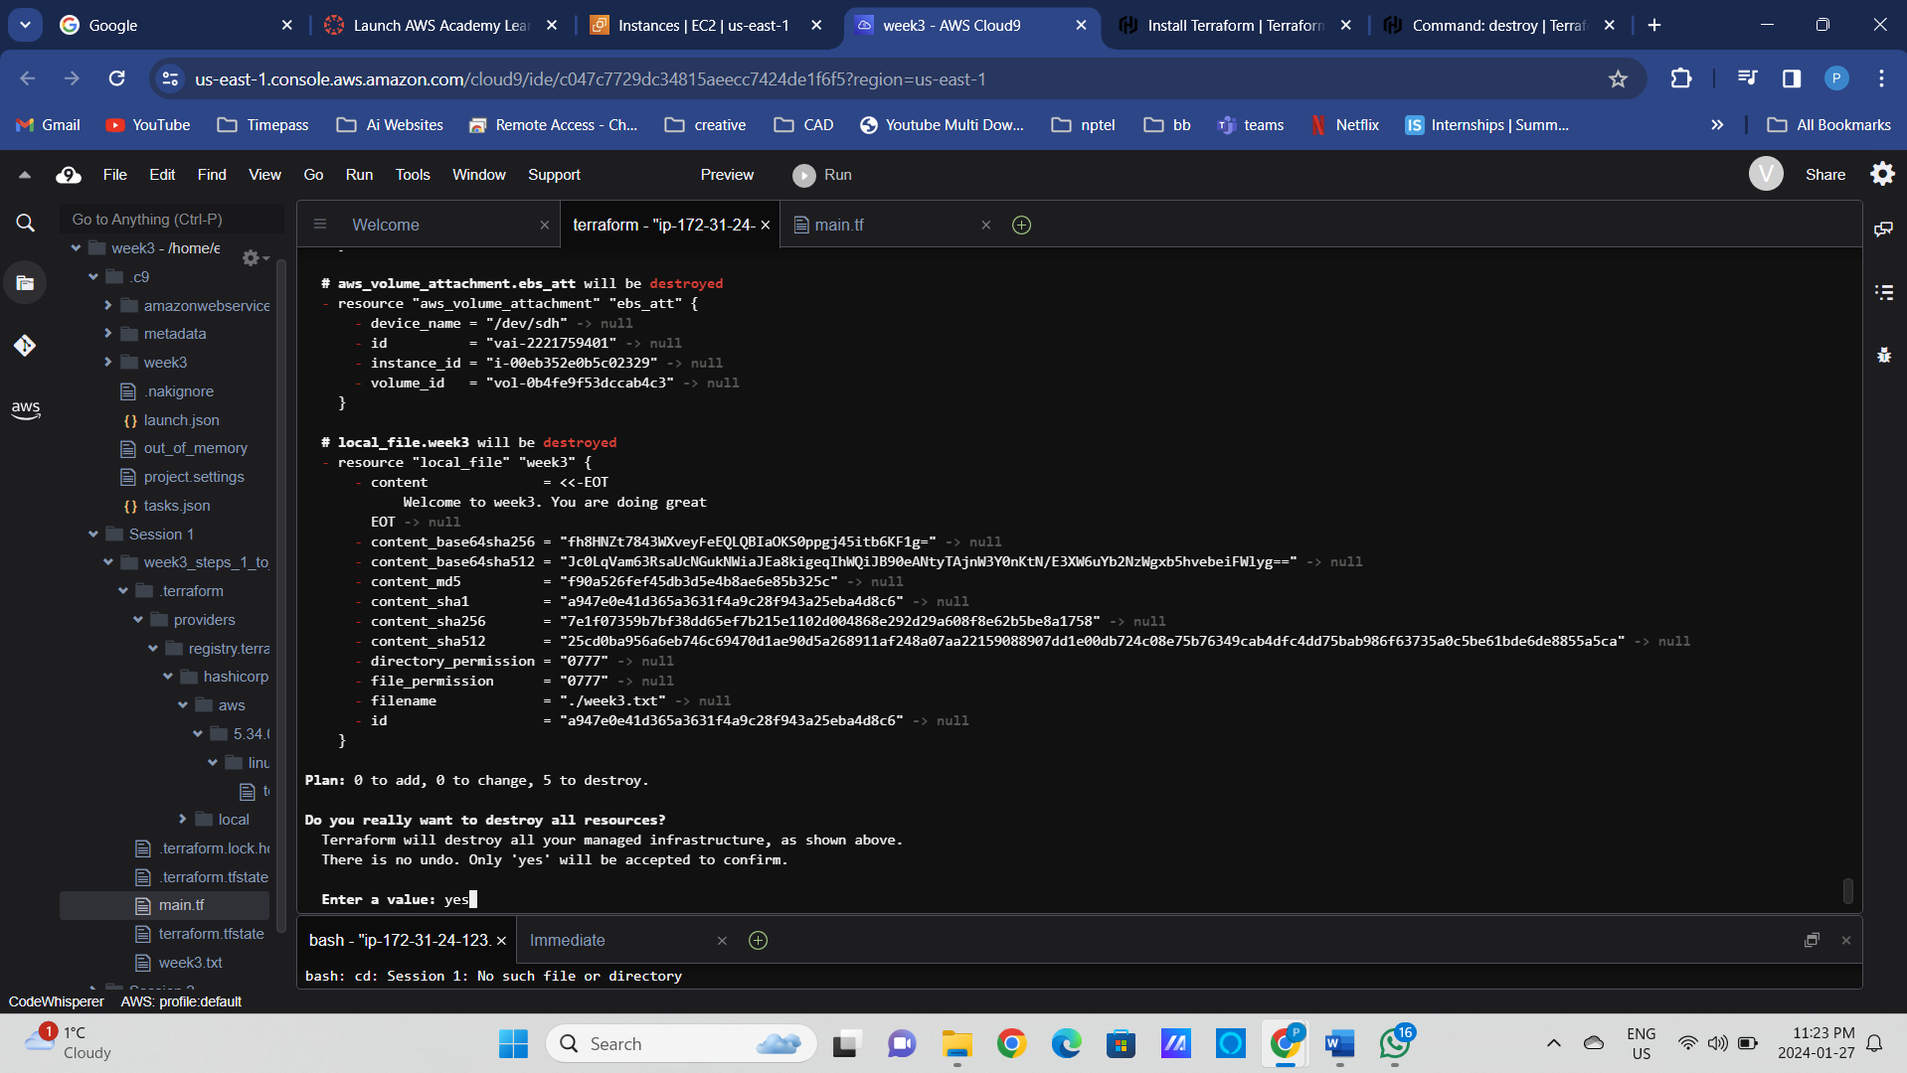

Comment few lines of codes

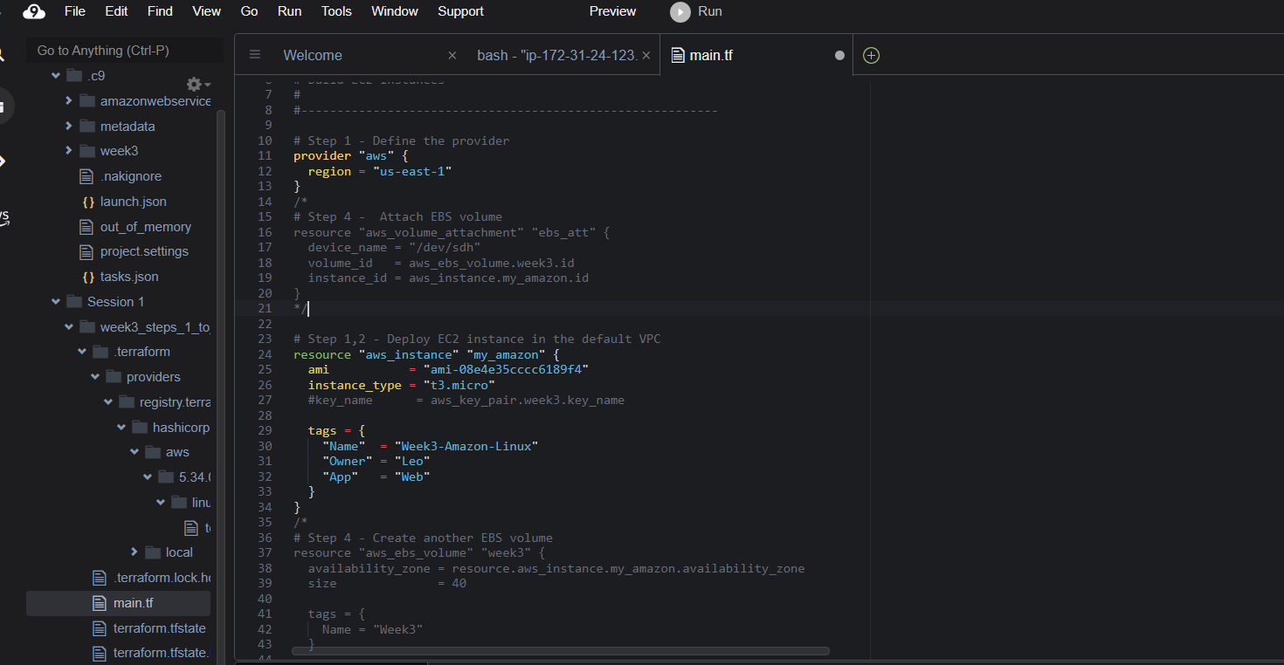

tf fmt

tf validate

tf plan

### Step4: Add additional data storage to the EC2 instance in the Terraform configuration file.

* Add code to deploy EBC volume and volume attachment. What Availability zone should we specify?   
  See “Task 4” in the provided main.tf in Lab folder.
* Run “terraform plan”, identify changes. Will the instance get redeployed?
* Deploy the changes with “terraform apply”.

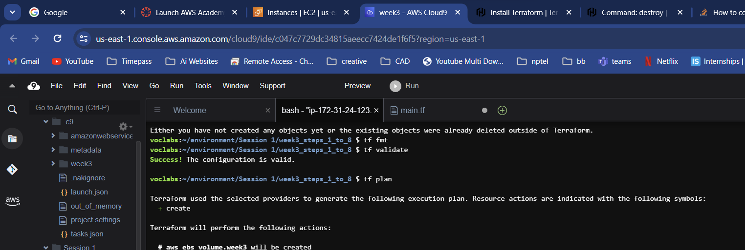

tf apply

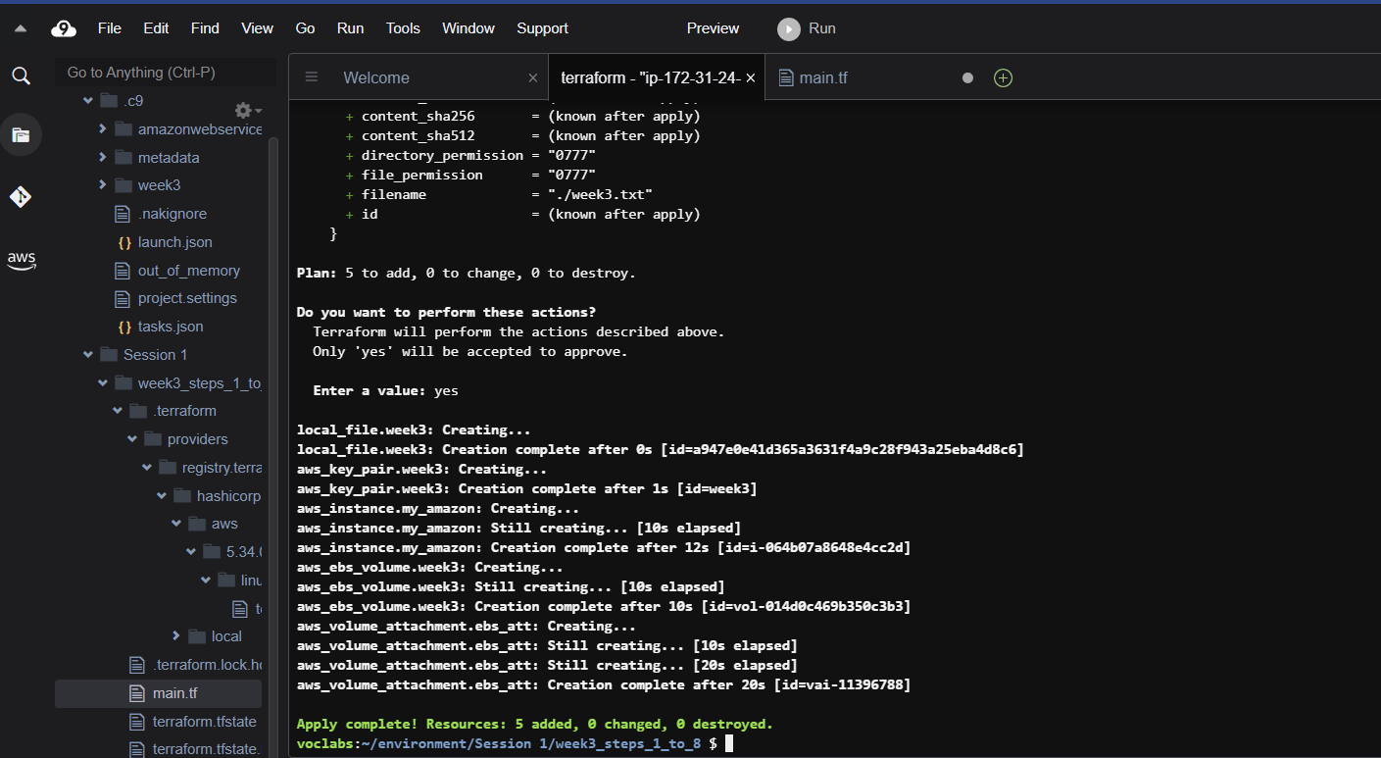

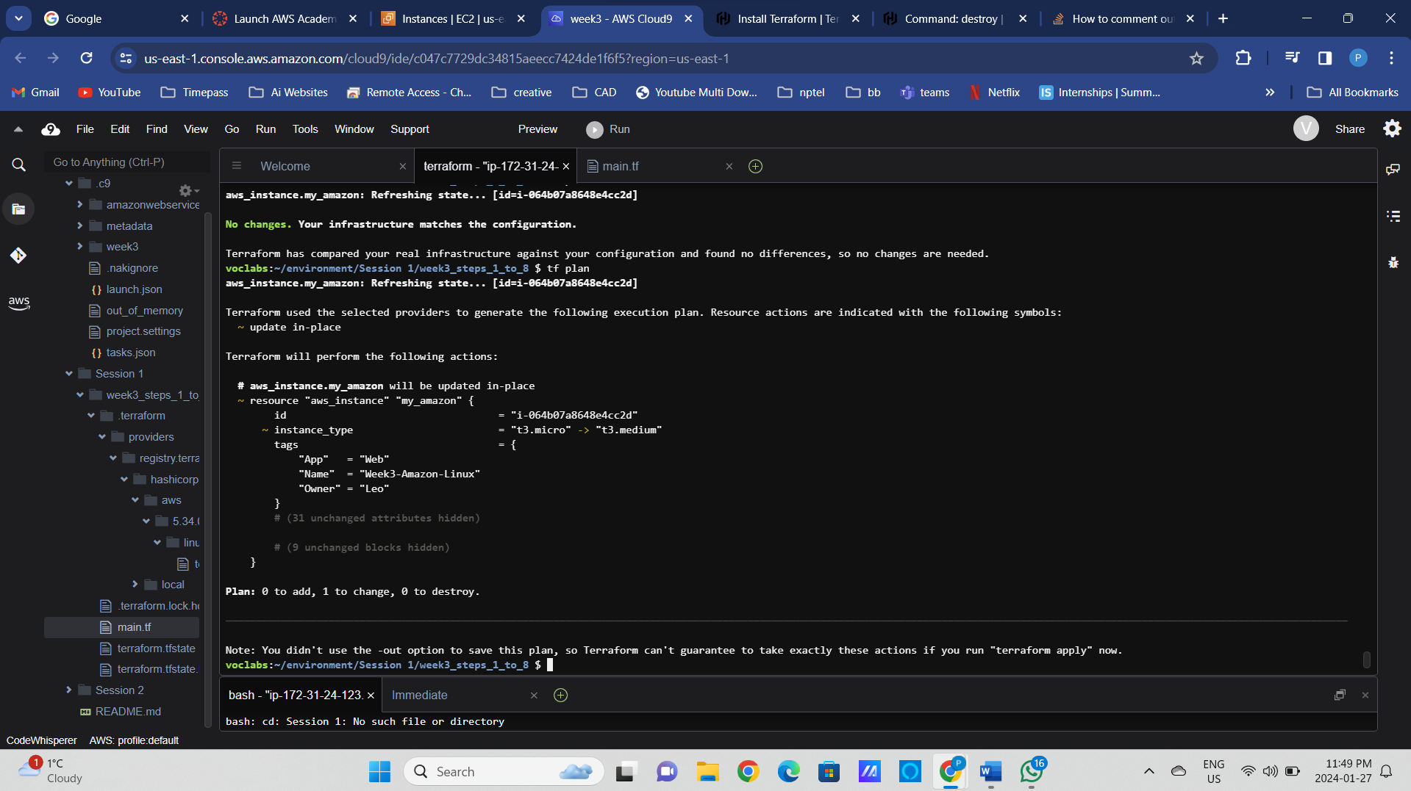

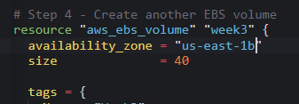

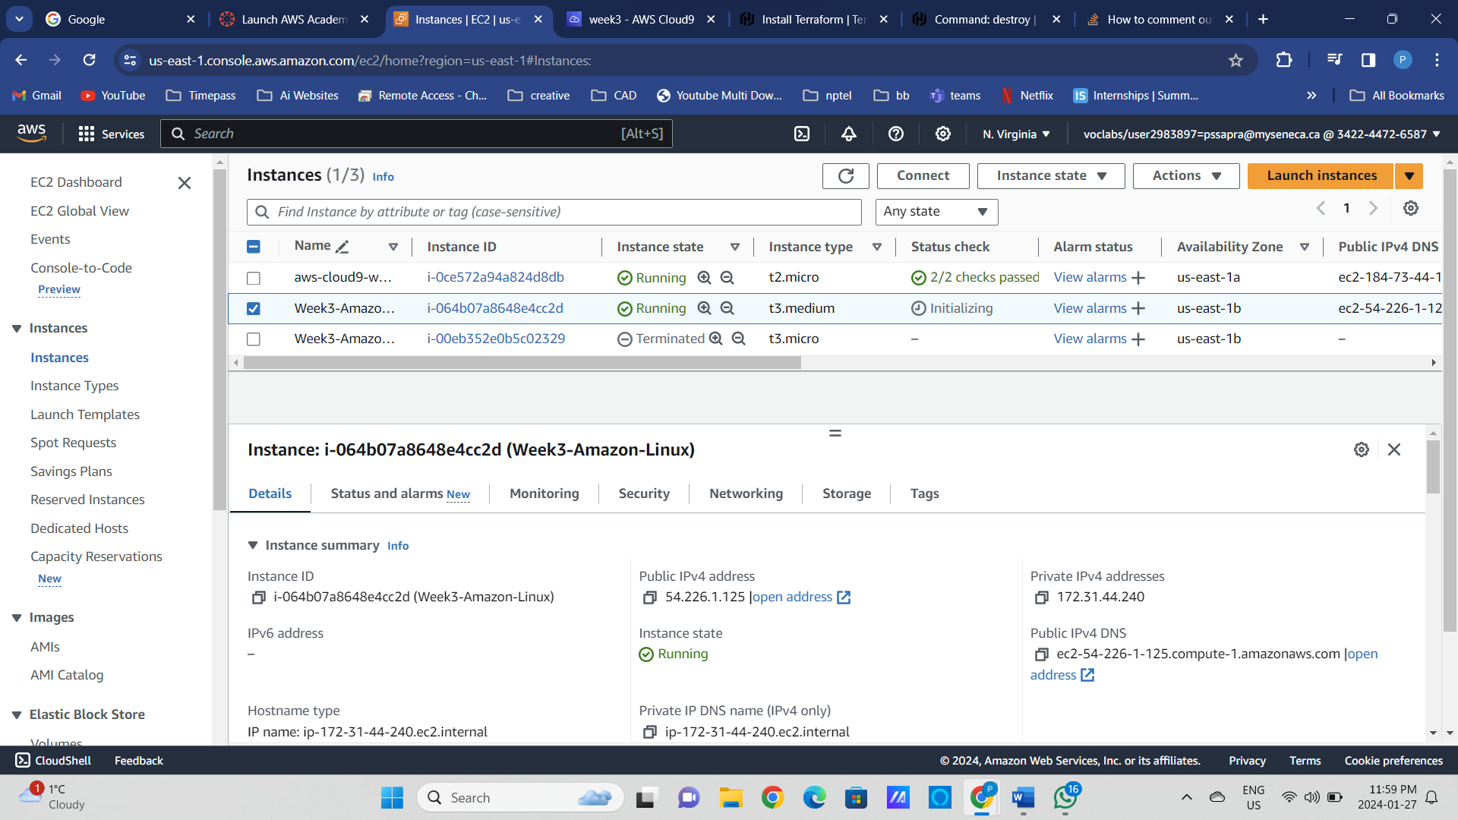

t3.medium added above

### Step5: Add ssh access key to the EC2 instance in the Terraform configuration file.

* Run “terraform plan”, identify changes. Will the instance get redeployed?
* Deploy the changes with terraform apply.

ssh-keygen -t rsa # Create a new SSH key pair

pwd

/home/ec2-user/environment/Session 1/week3_steps_1_to_8

/home/ec2-user/environment/Session 1/week3_steps_1_to_8/id_rsa

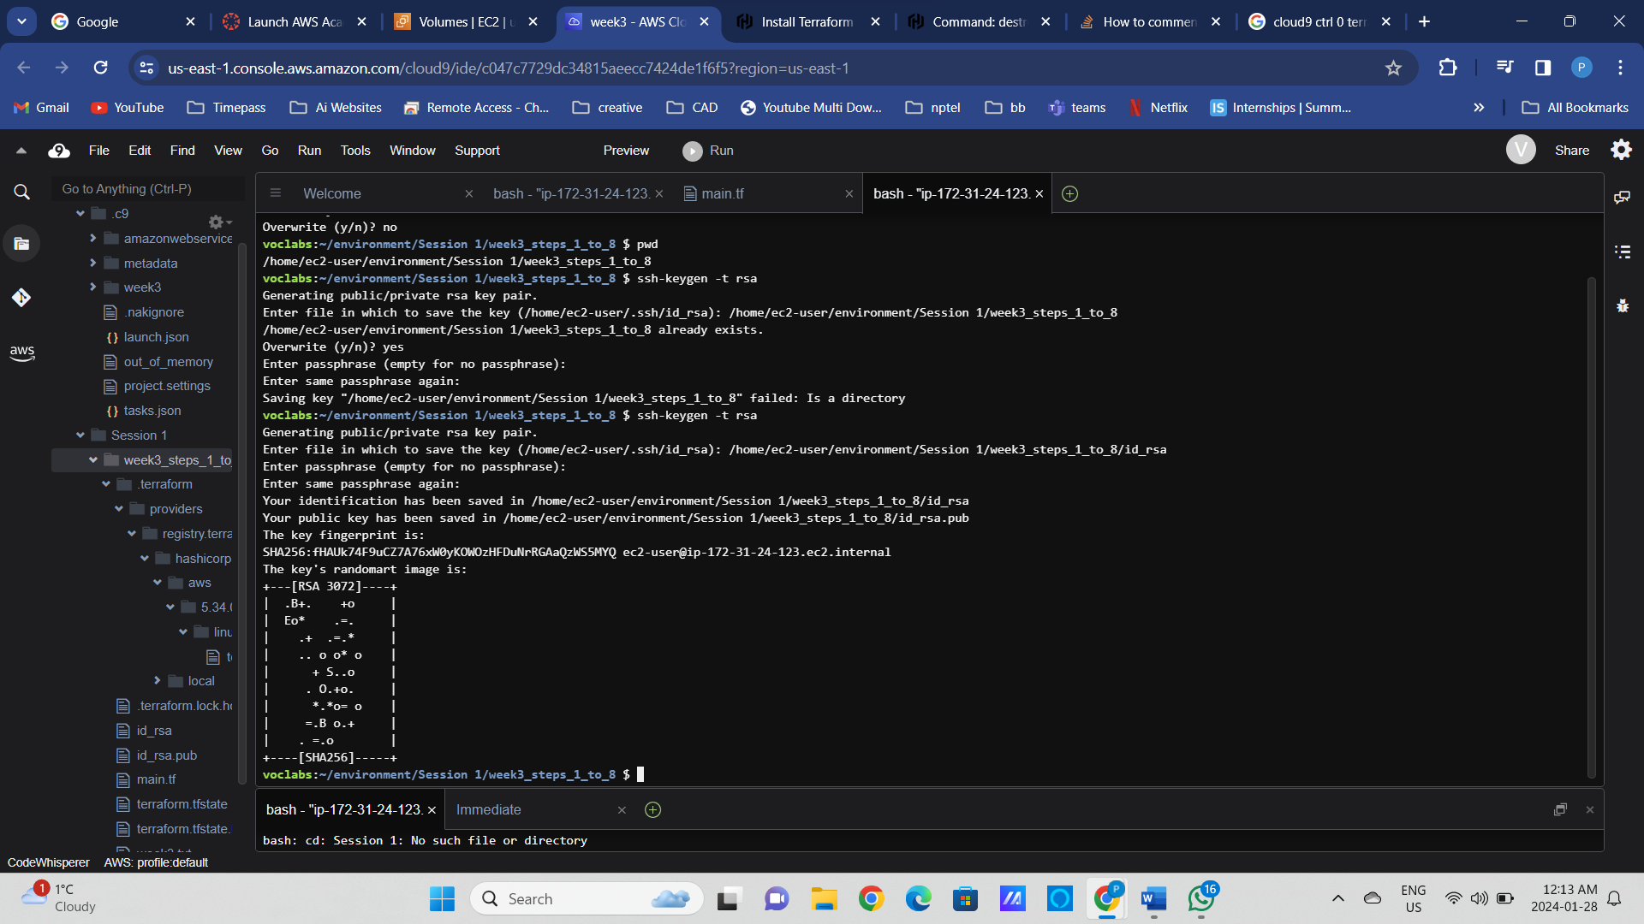

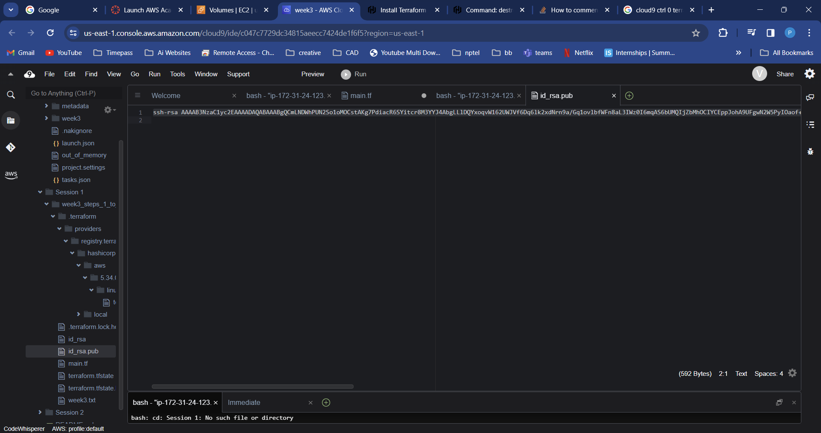

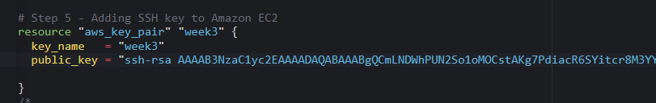

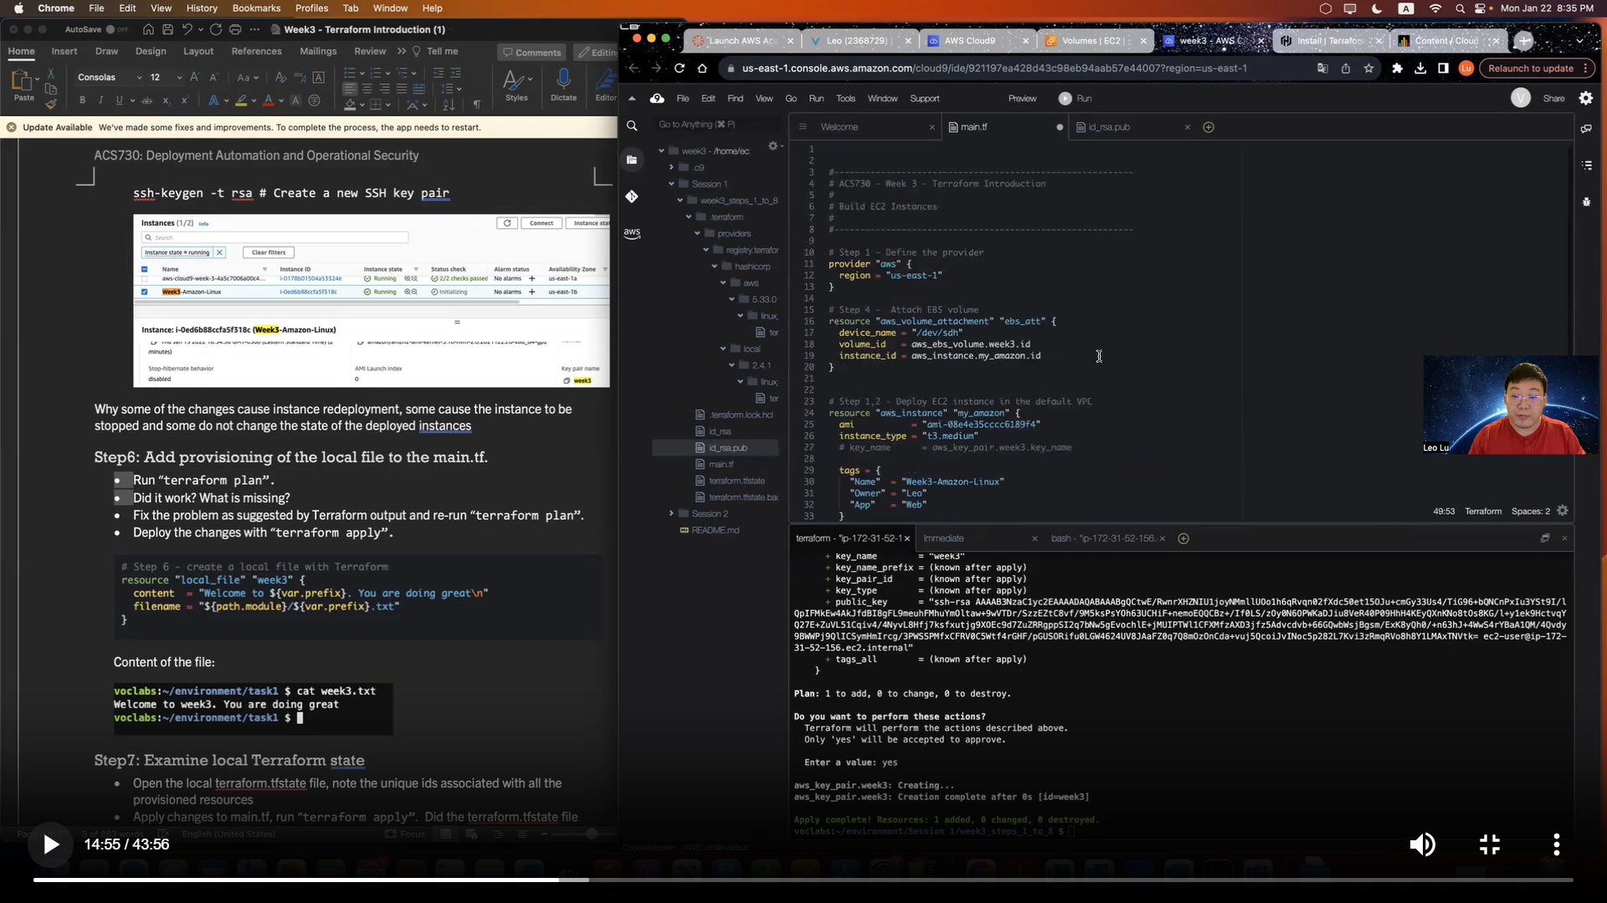

### Step6: Add [provisioning of the local file](https://registry.terraform.io/providers/hashicorp/local/latest/docs/resources/file) to the main.tf.

* Run “terraform plan”.
* Did it work? What is missing?
* Fix the problem as suggested by Terraform output and re-run “terraform plan”.
* Deploy the changes with “terraform apply”.

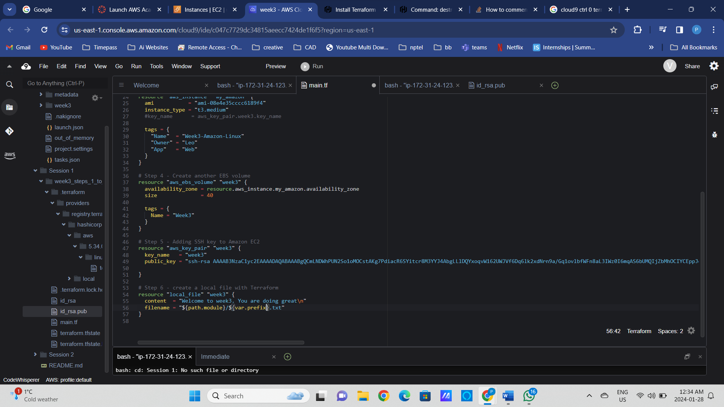

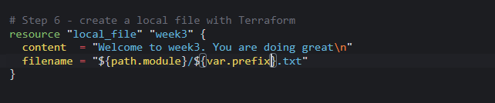 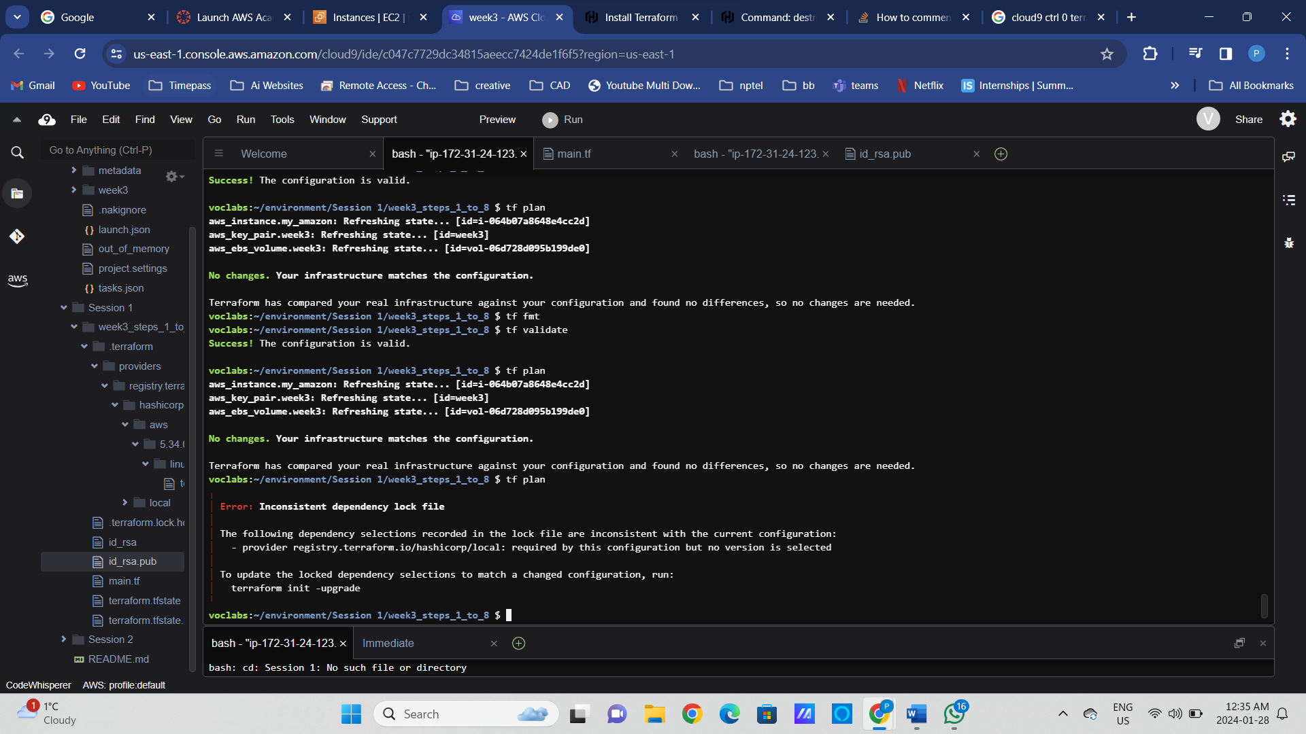



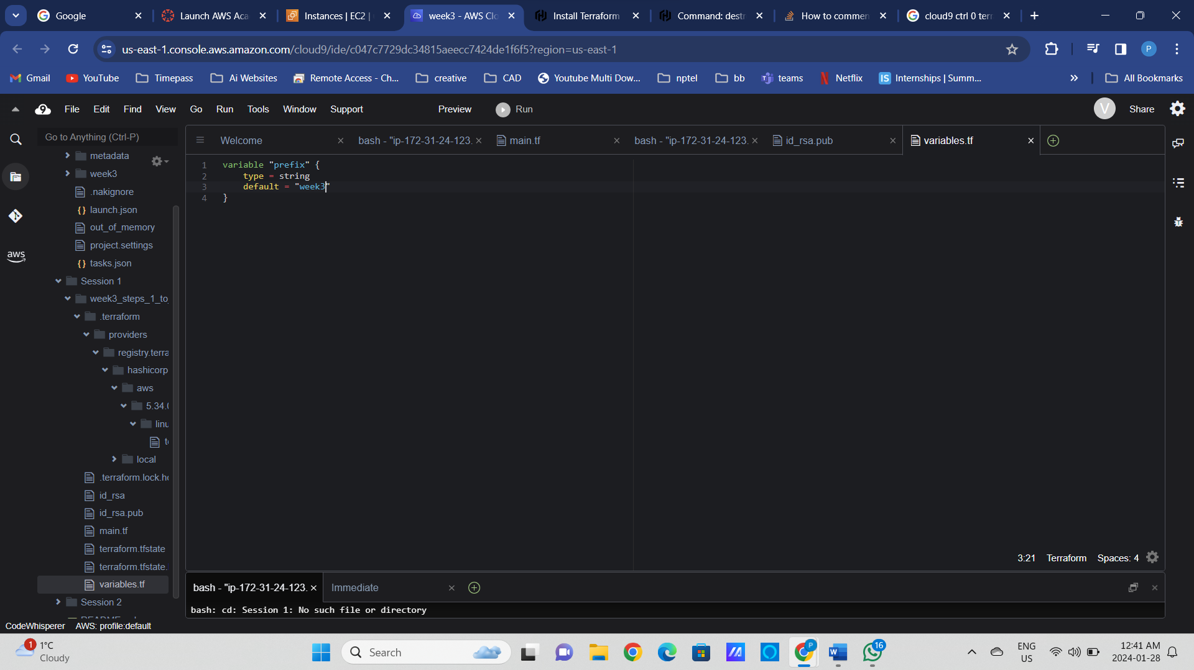

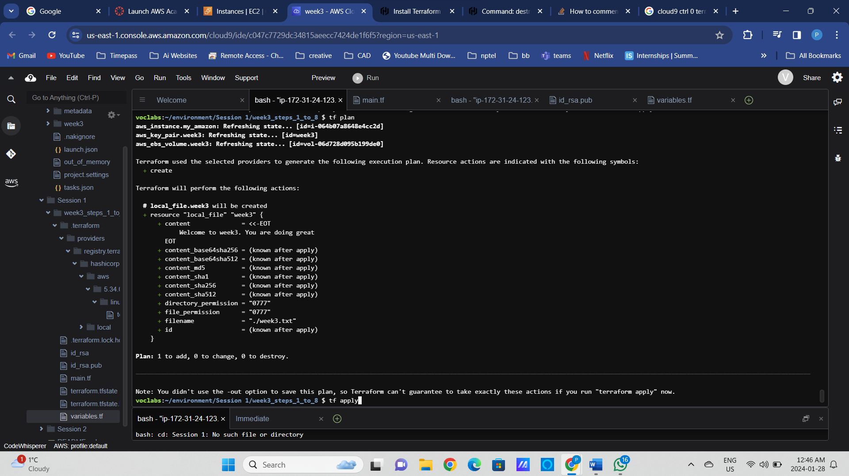

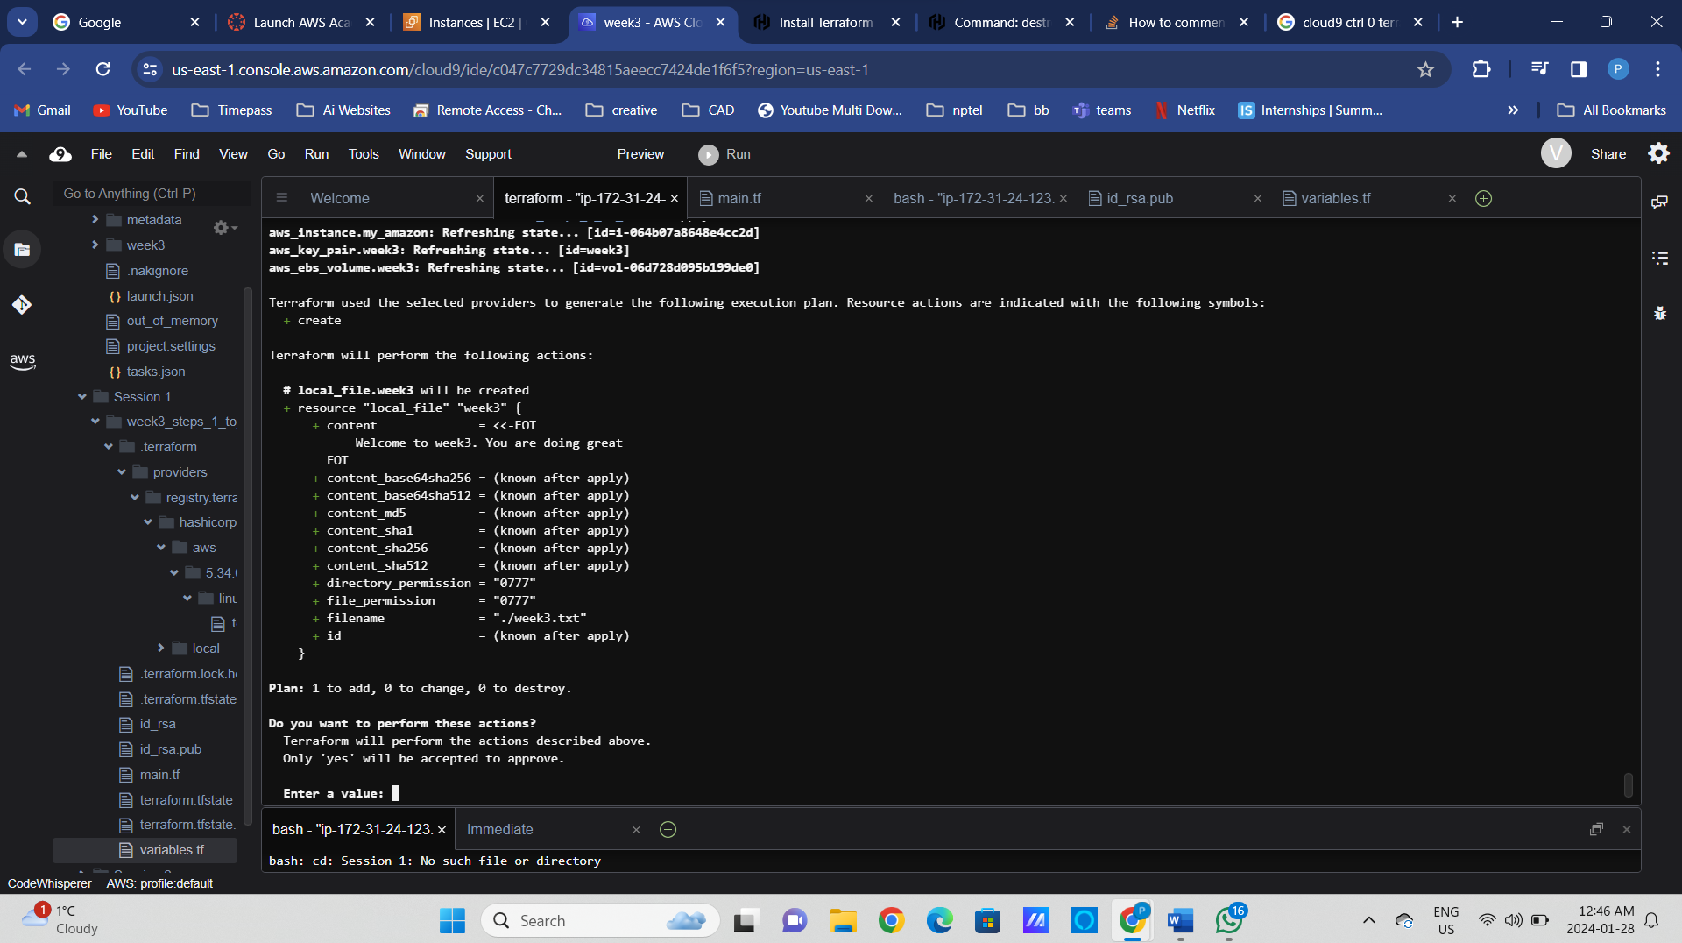

Content of the file:

### 

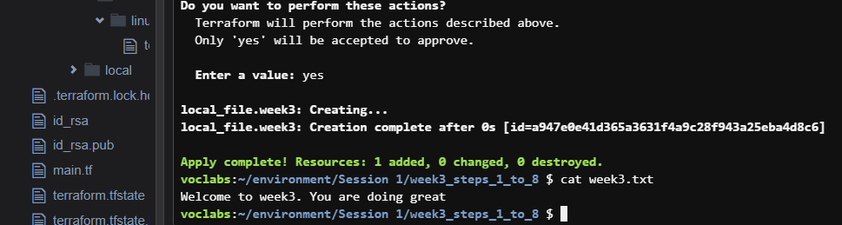

### Step7: Examine local Terraform state

* Open the local terraform.tfstate file, note the unique ids associated with all the provisioned resources
* Apply changes to main.tf, run “terraform apply”. Did the terraform.tfstate file change?
* Remove the local file from main.tf and run “terraform apply”. Did the terraform.tfstate file change?

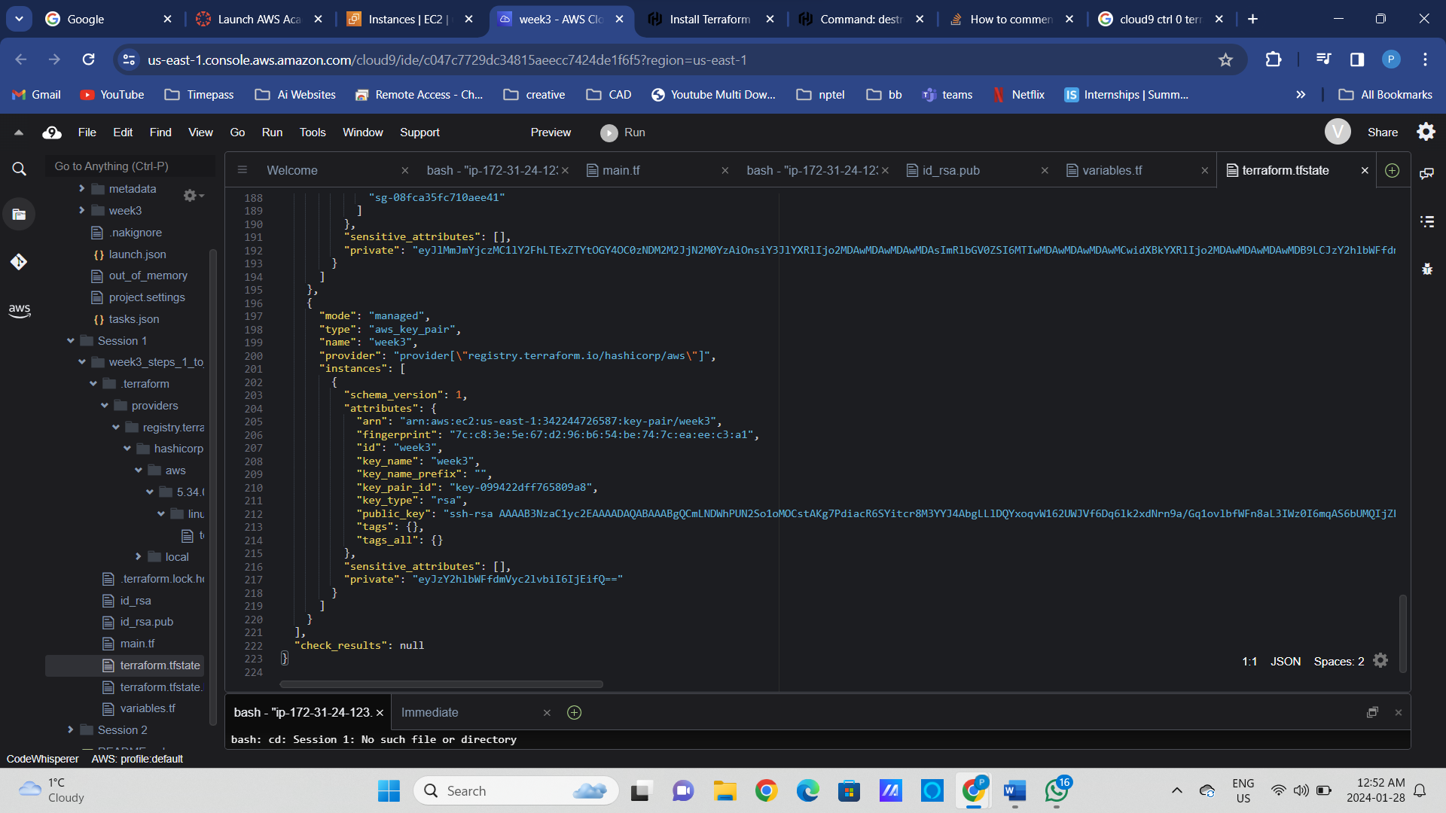

### 

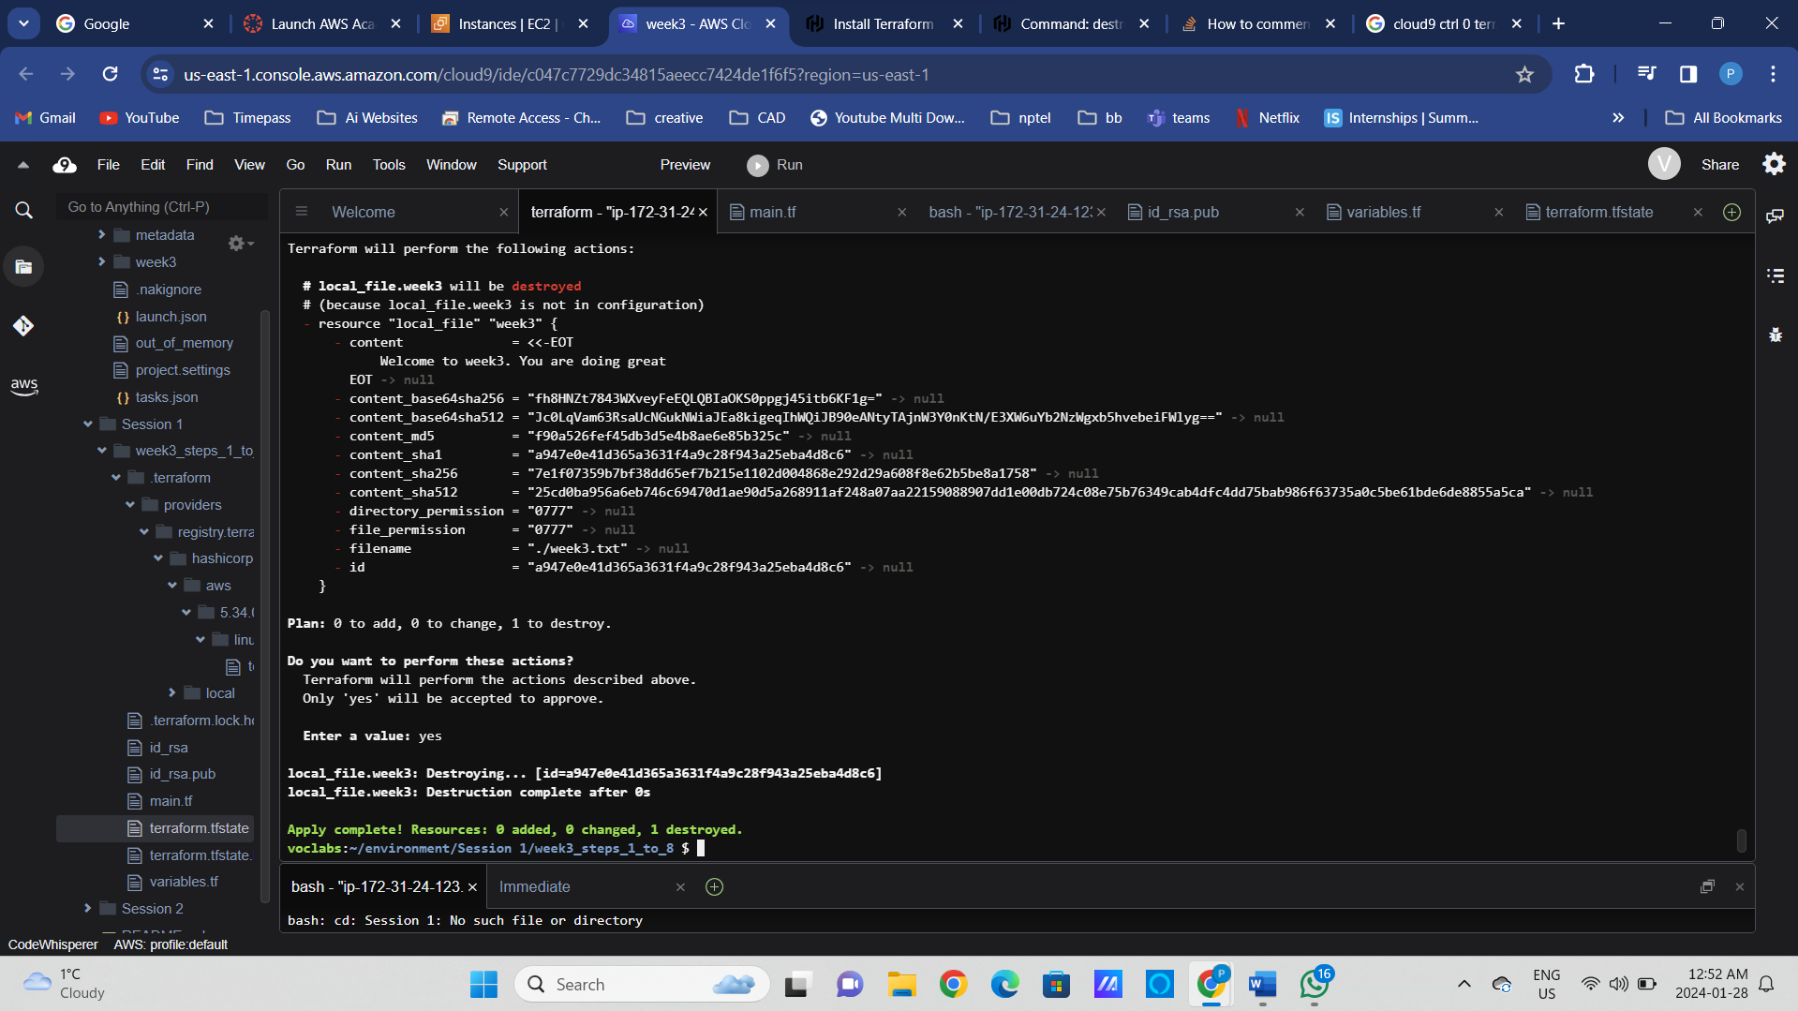

### Step8: Add variables.tf file and provide all the parameters using the options below.

Run “terraform plan” for all the provided options.

* Scalar variables and default values in variables.tf
* Map variables and default values in variables.tf
* As input flags with –var

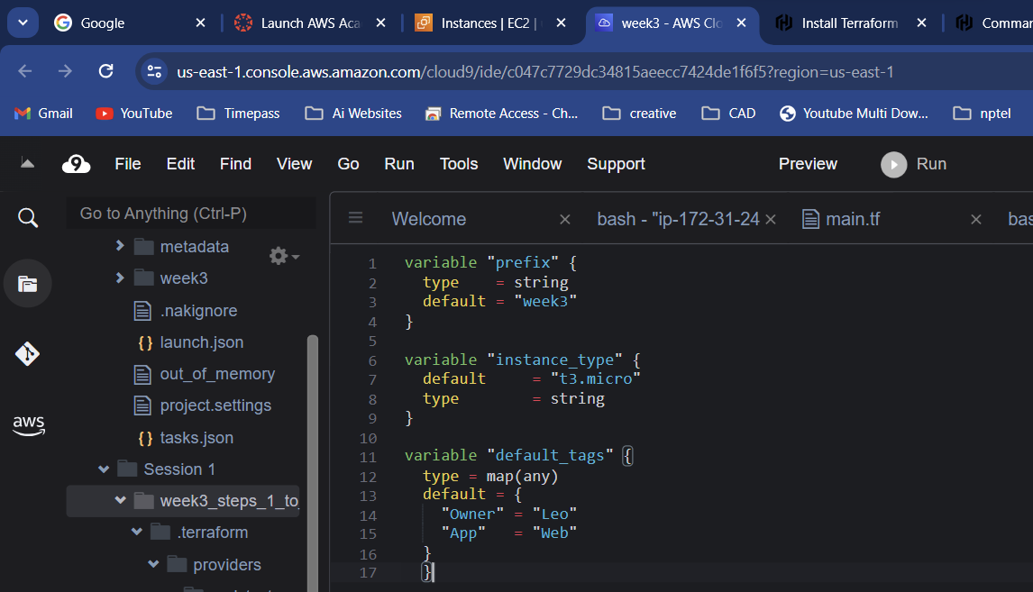

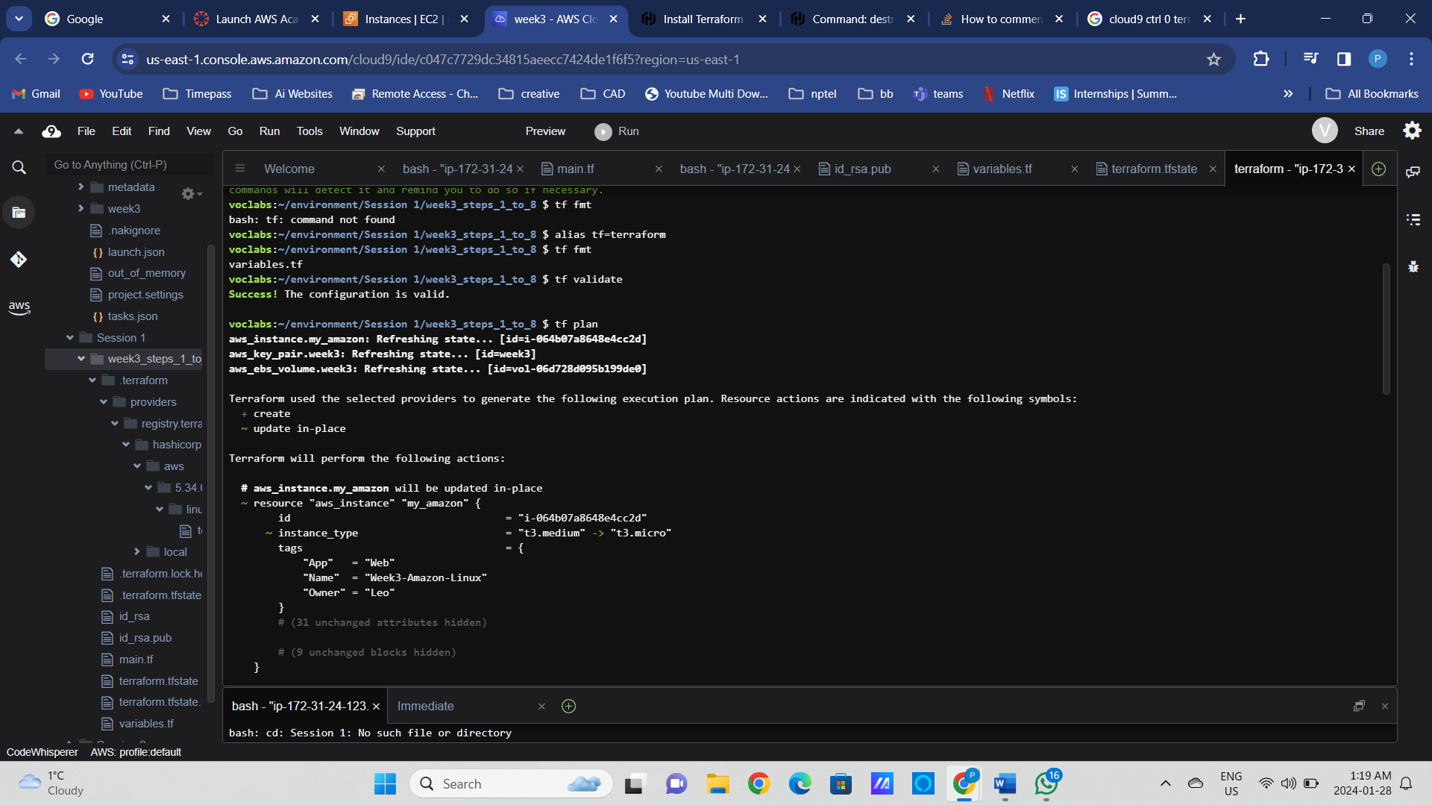

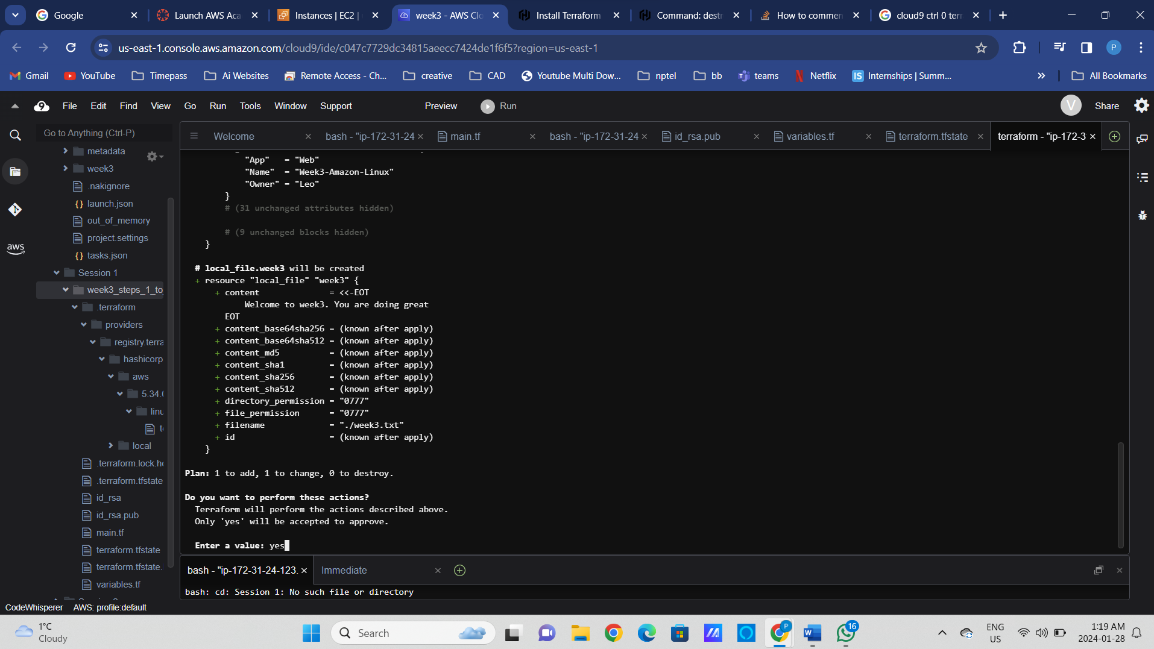

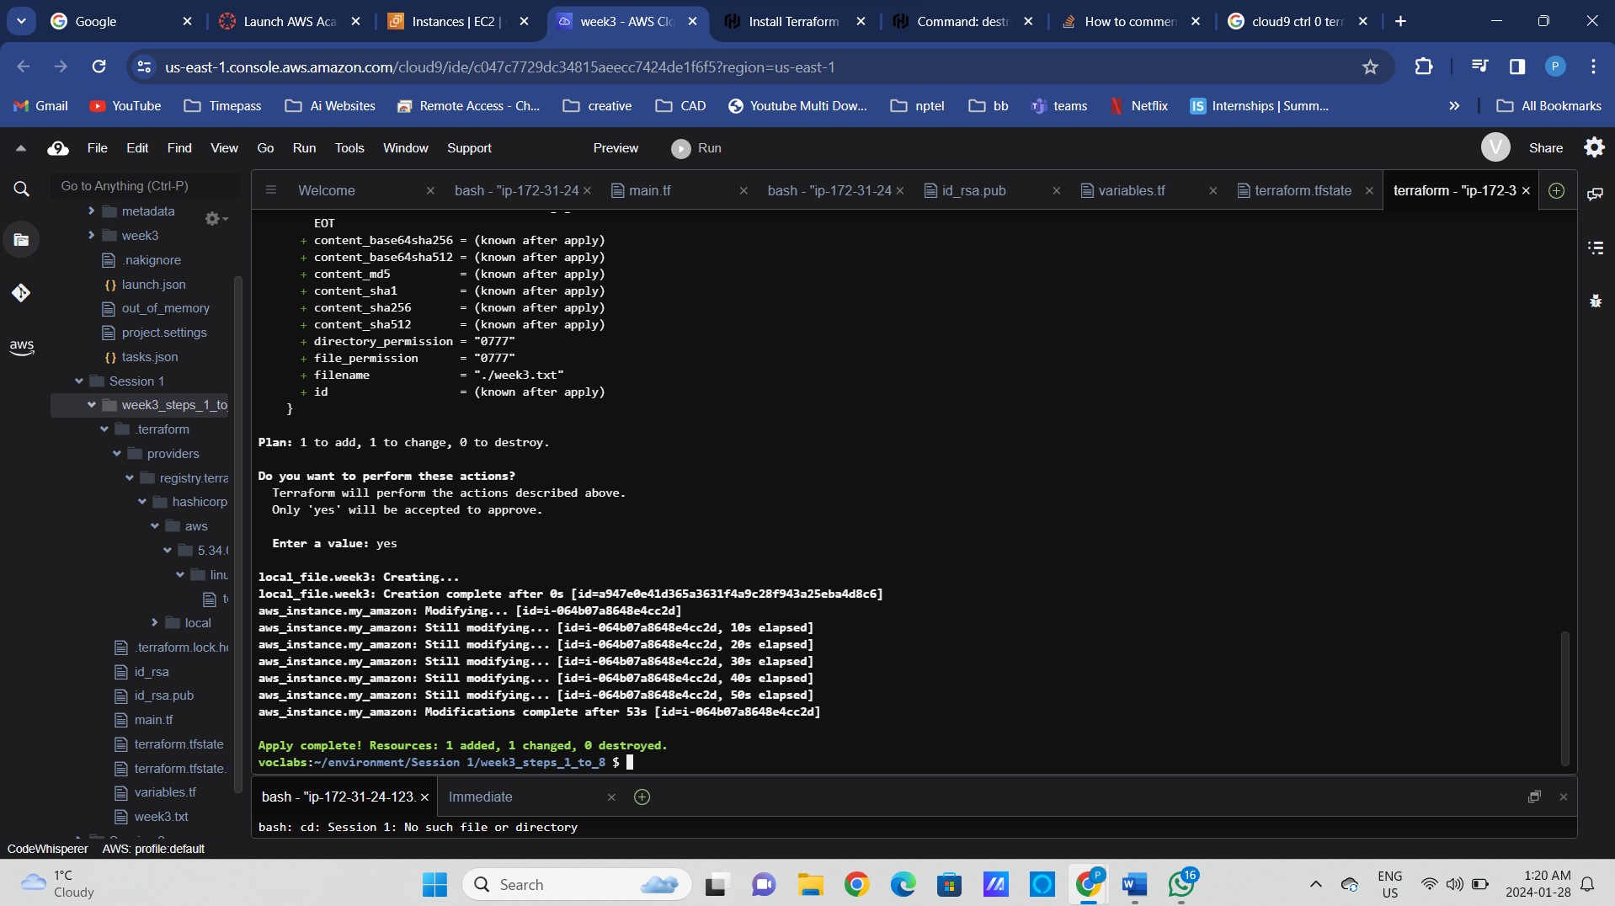

tf apply --auto-approve --var prefix="week4"

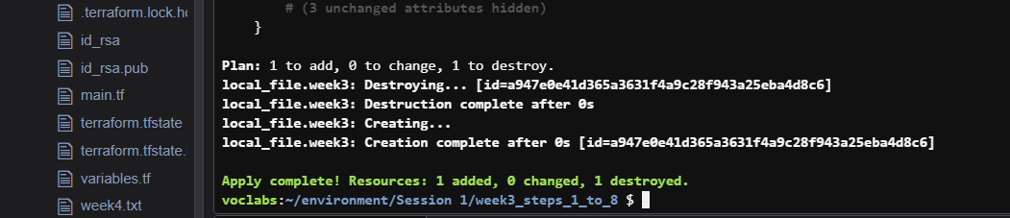

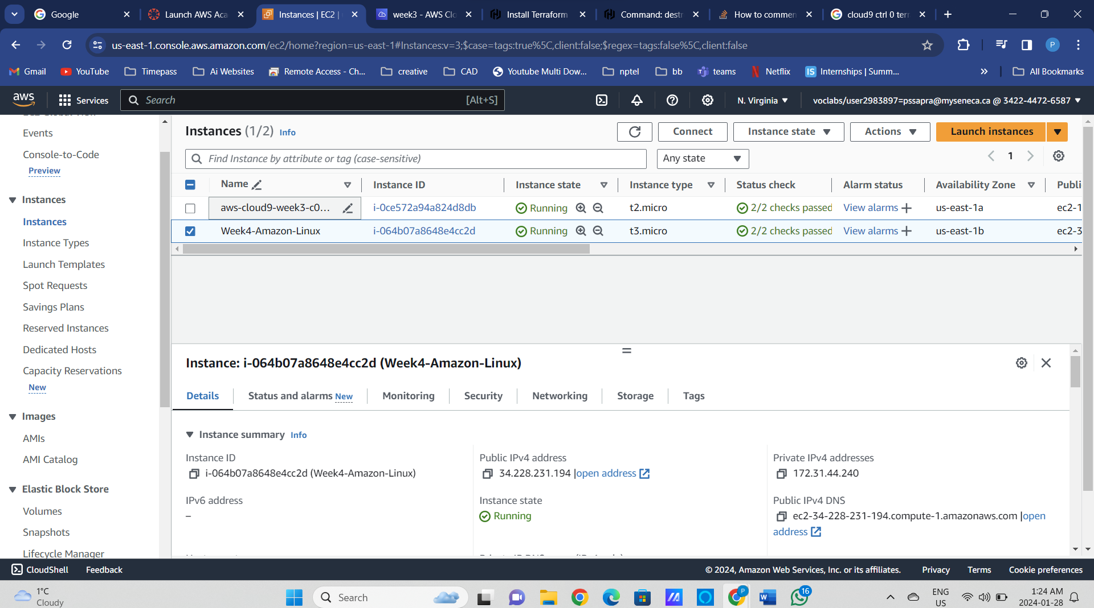

Session 1 Completed!

Session 2

### Step9: Add provisioning of the public subnet to the main.tf and update EC2 resource block to ensure EC2 is deployed into a newly provisioned subnet.

* Is this an explicit or implicit dependency?
* Did the code work or errored out?

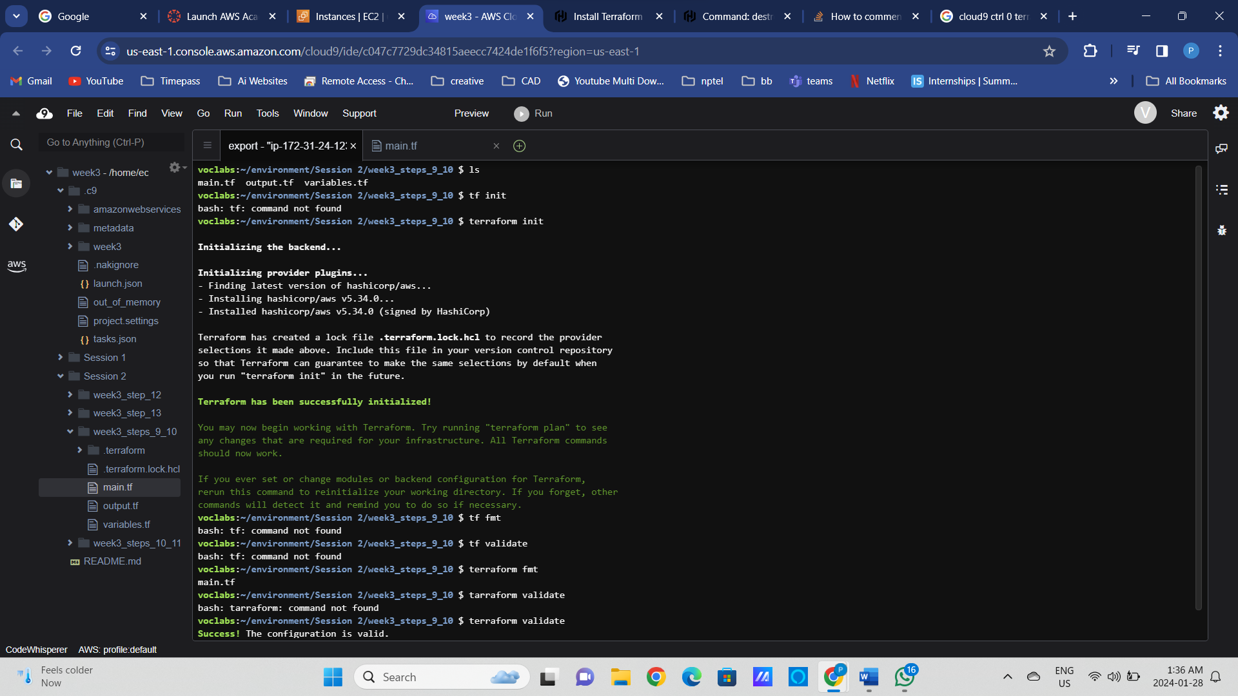

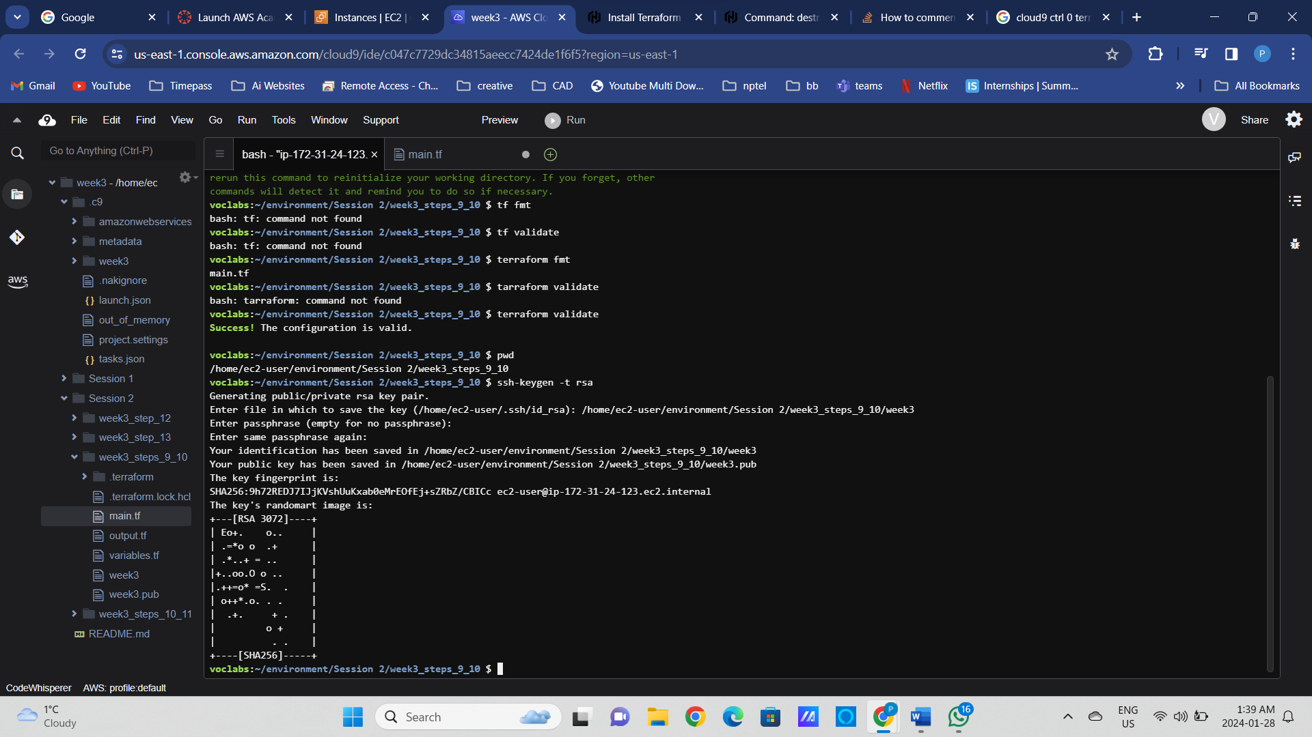

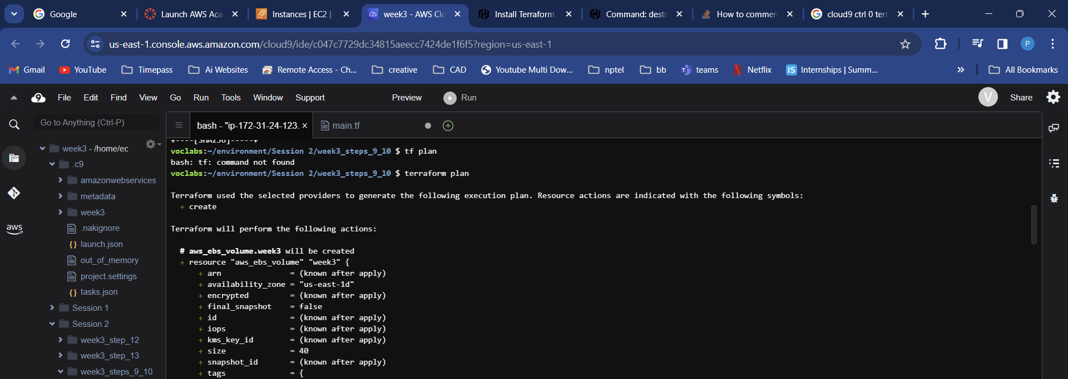

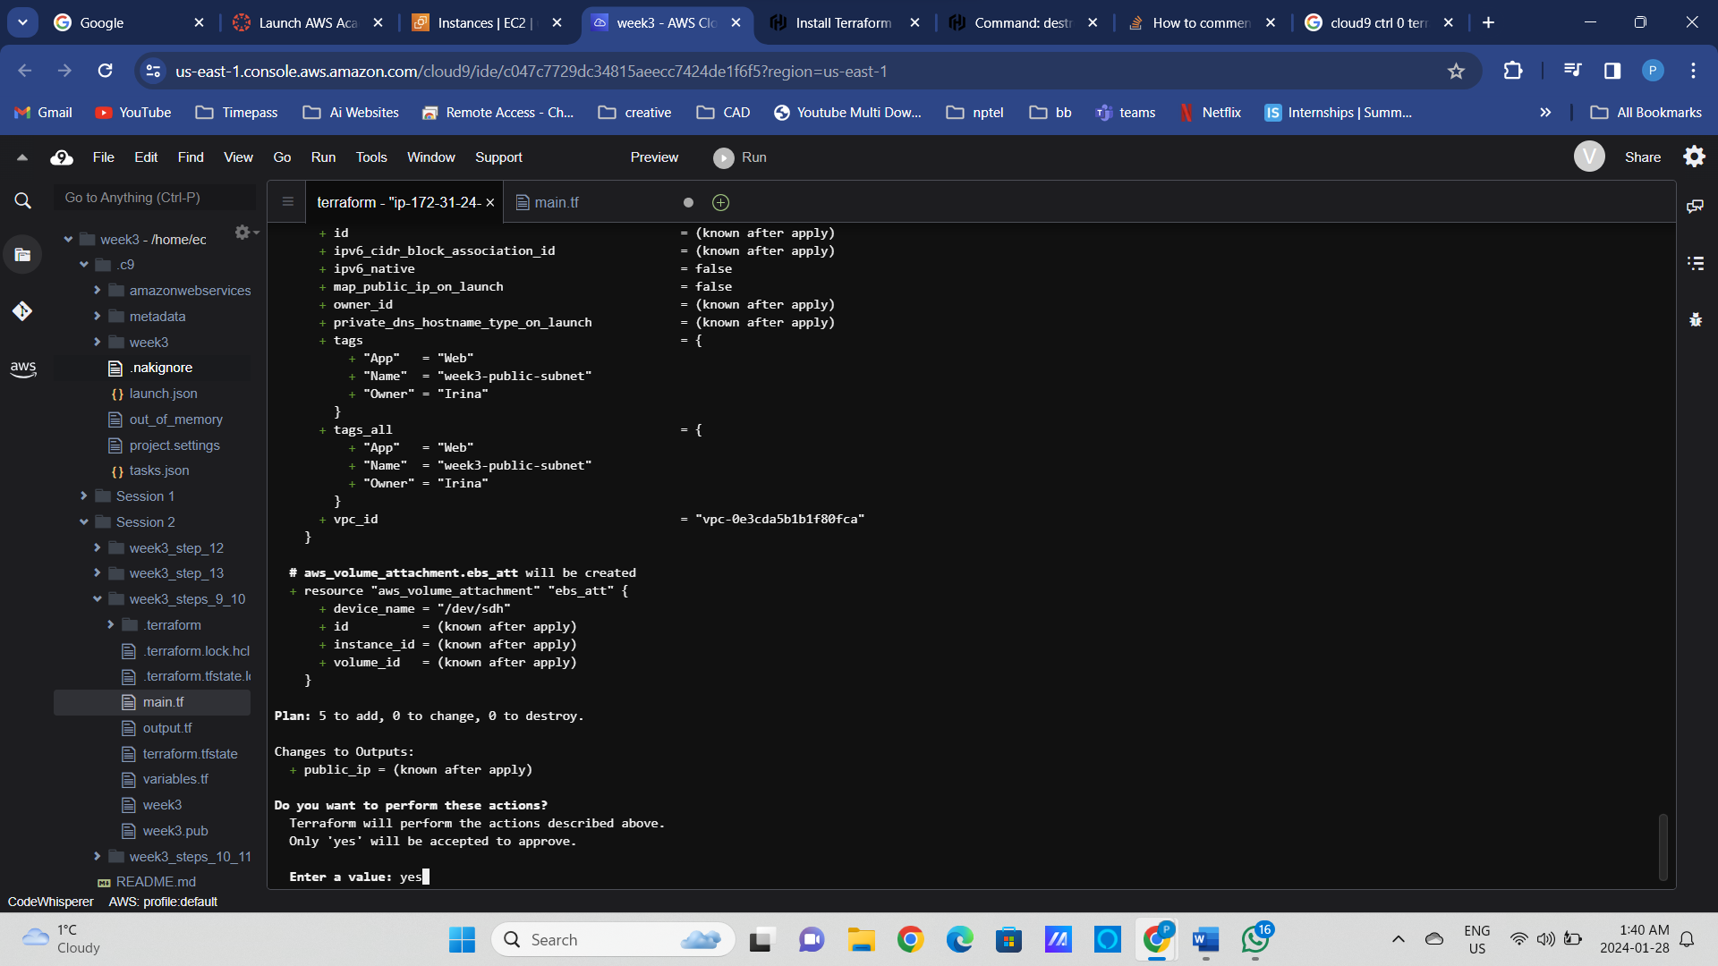

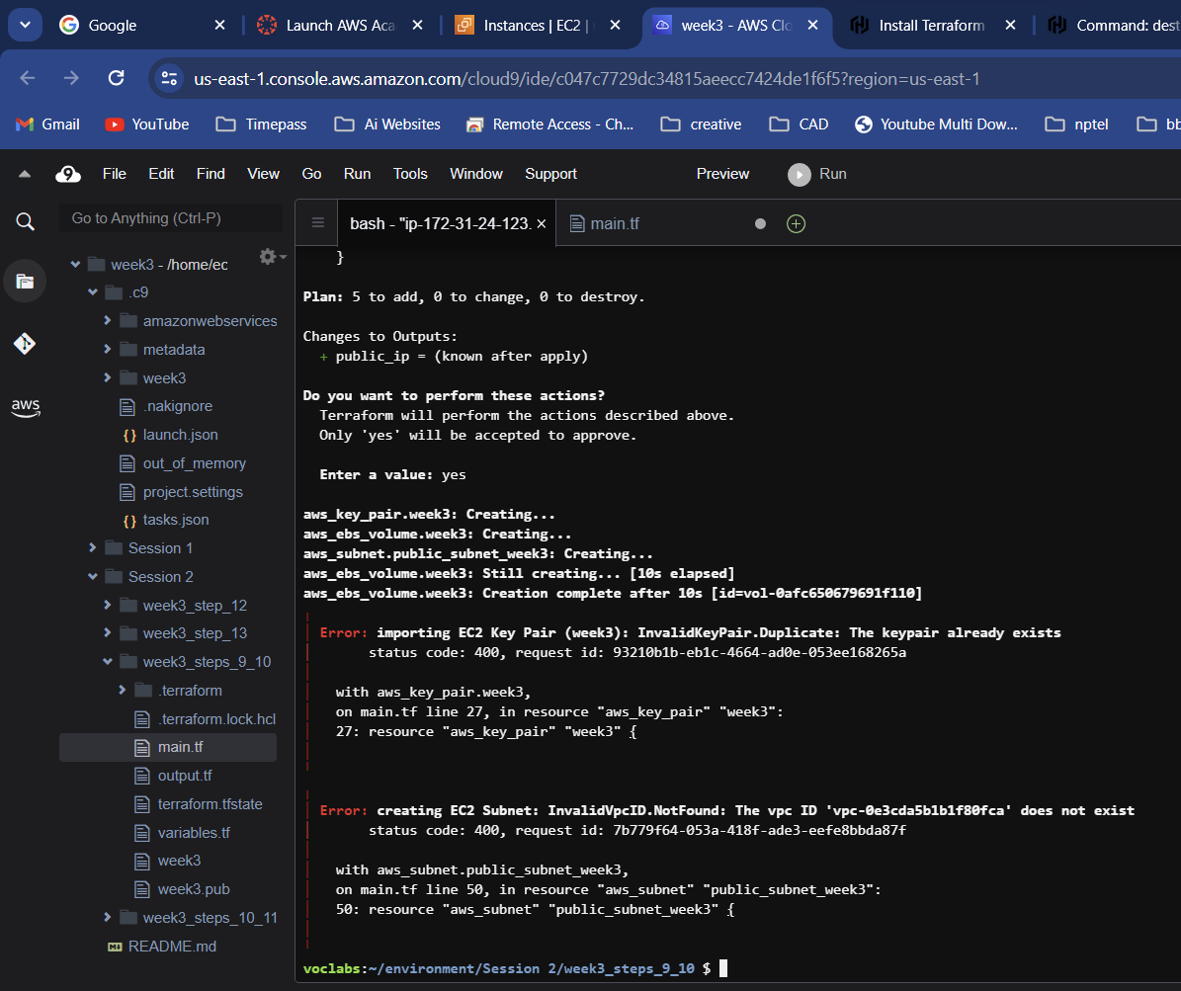

Delete the week3 in the Key pair

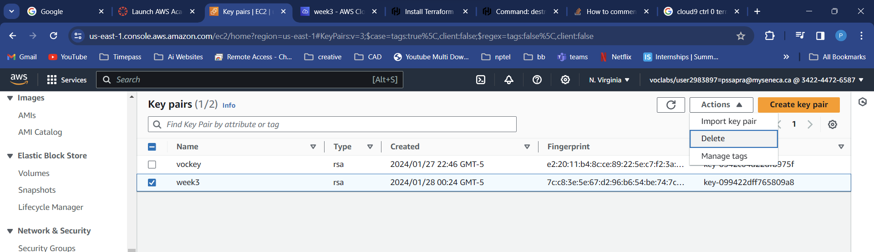

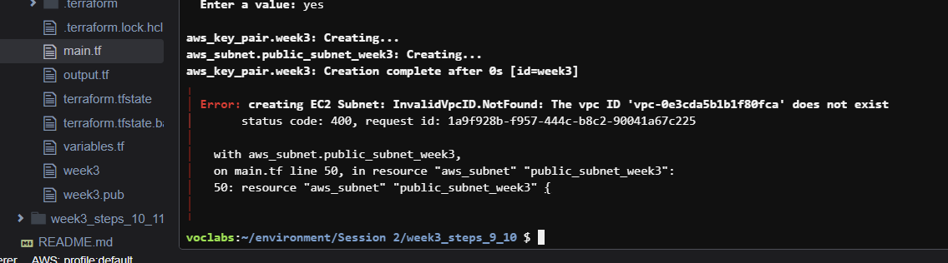

Import week3 keypair again from the week3.pub

And comment this section

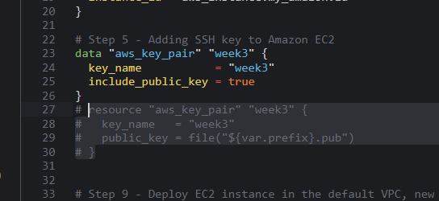

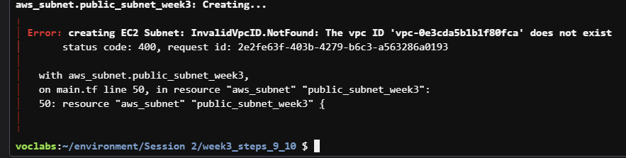

In this error VPC is the issue now go to AWS and find Your VPCs and copy the id

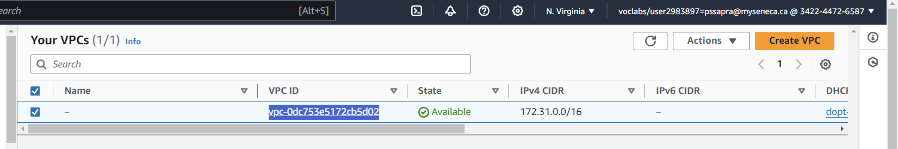

And paste it in the variables.tf step 9

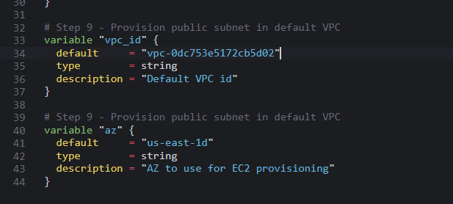

terraform apply -var vpc_id=vpc-0dc753e5172cb5d02

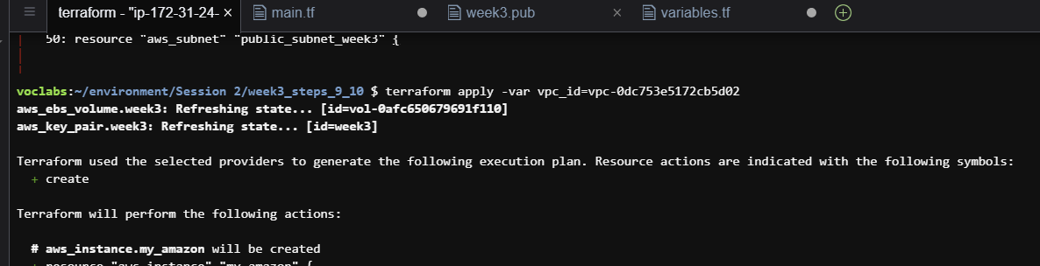

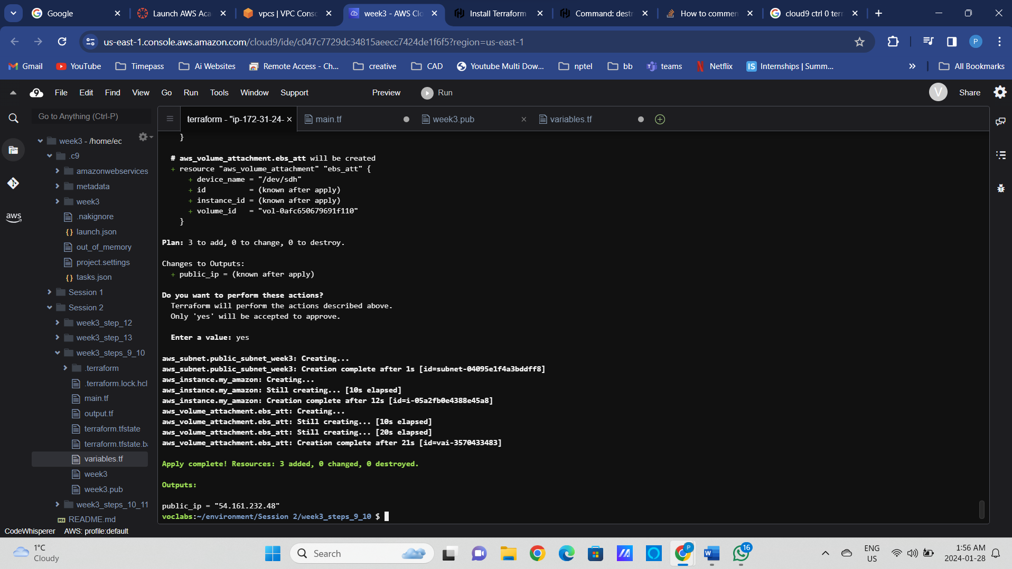

### Step10: Add output variables and print them out with the terraform output command

&

### Step11: Introducing backend block and the remote Terraform state

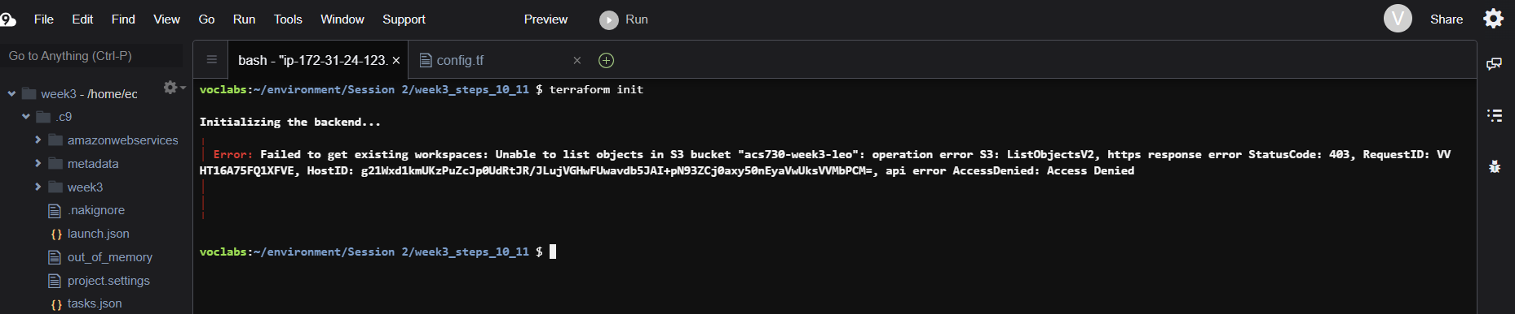

Now copy bucket from config.tf

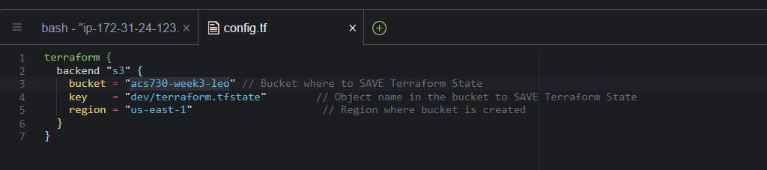

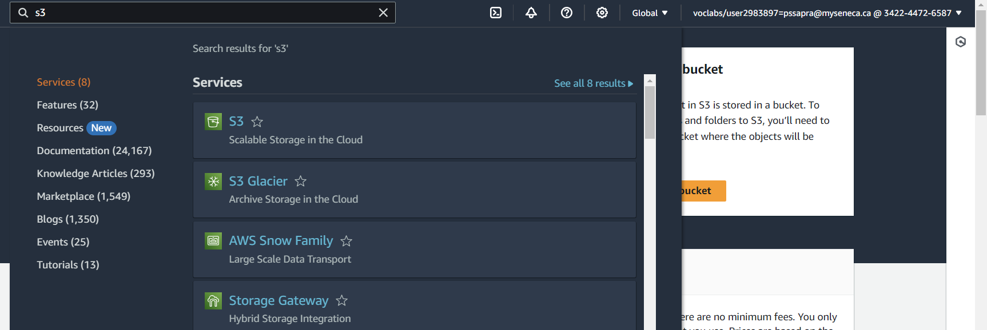

Create bucket

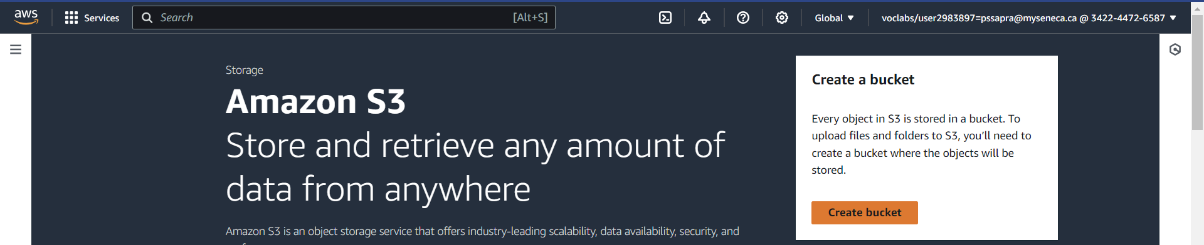

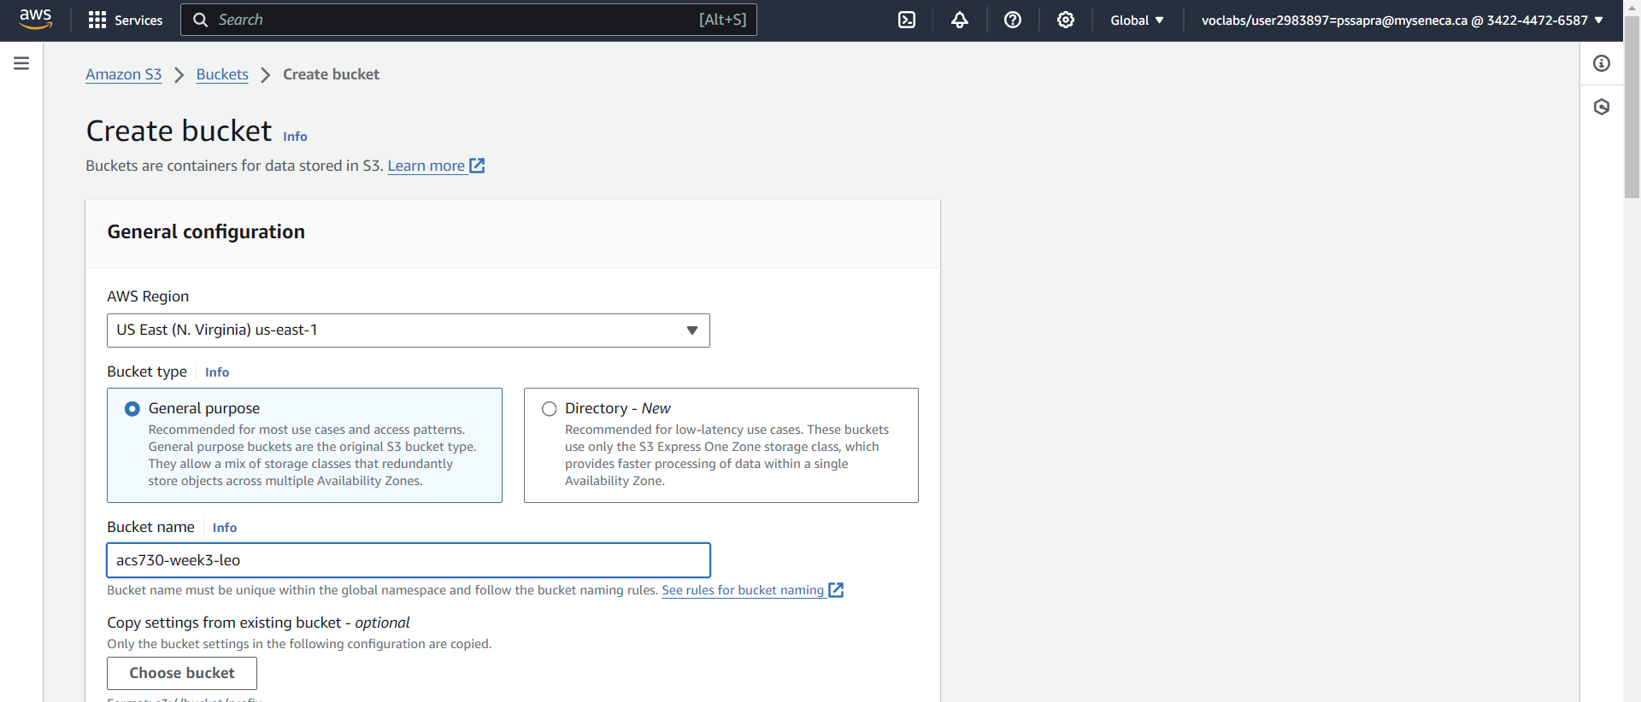

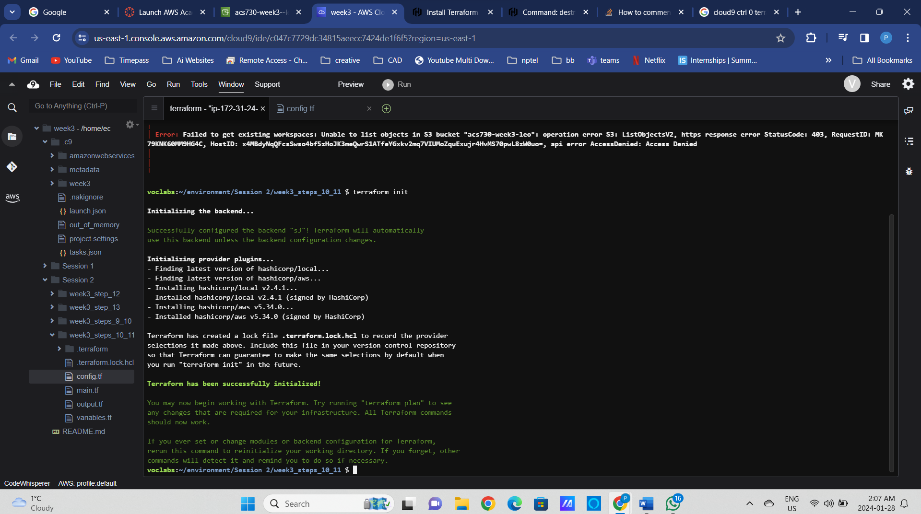

Now comment and uncomment Step 5 of the code

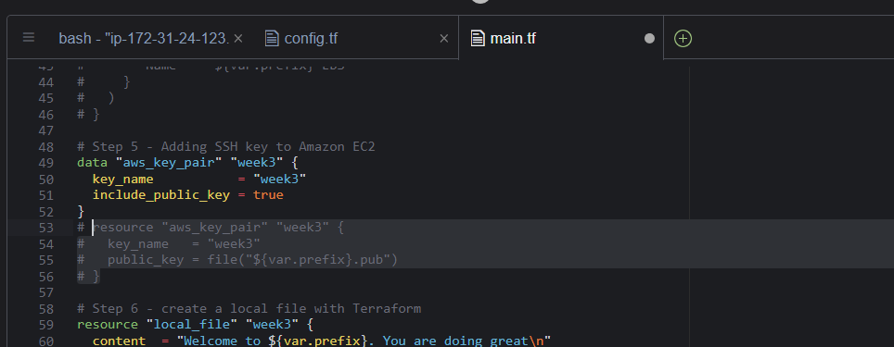

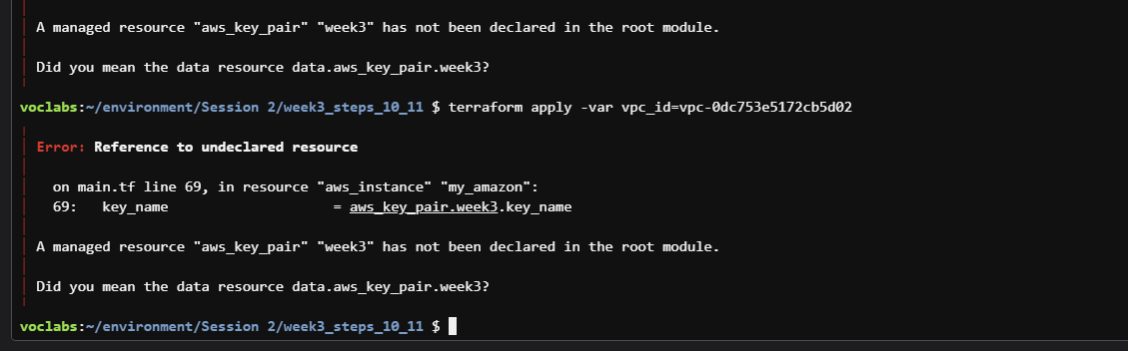

Get the cidr block from your VPCs

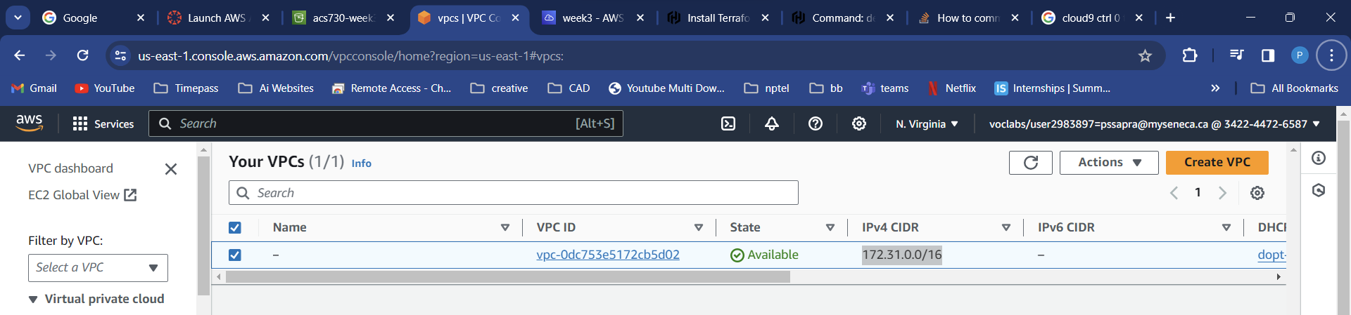

terraform apply -var vpc_id=vpc-0dc753e5172cb5d02 -var cidr_block=172.31.0.0/16

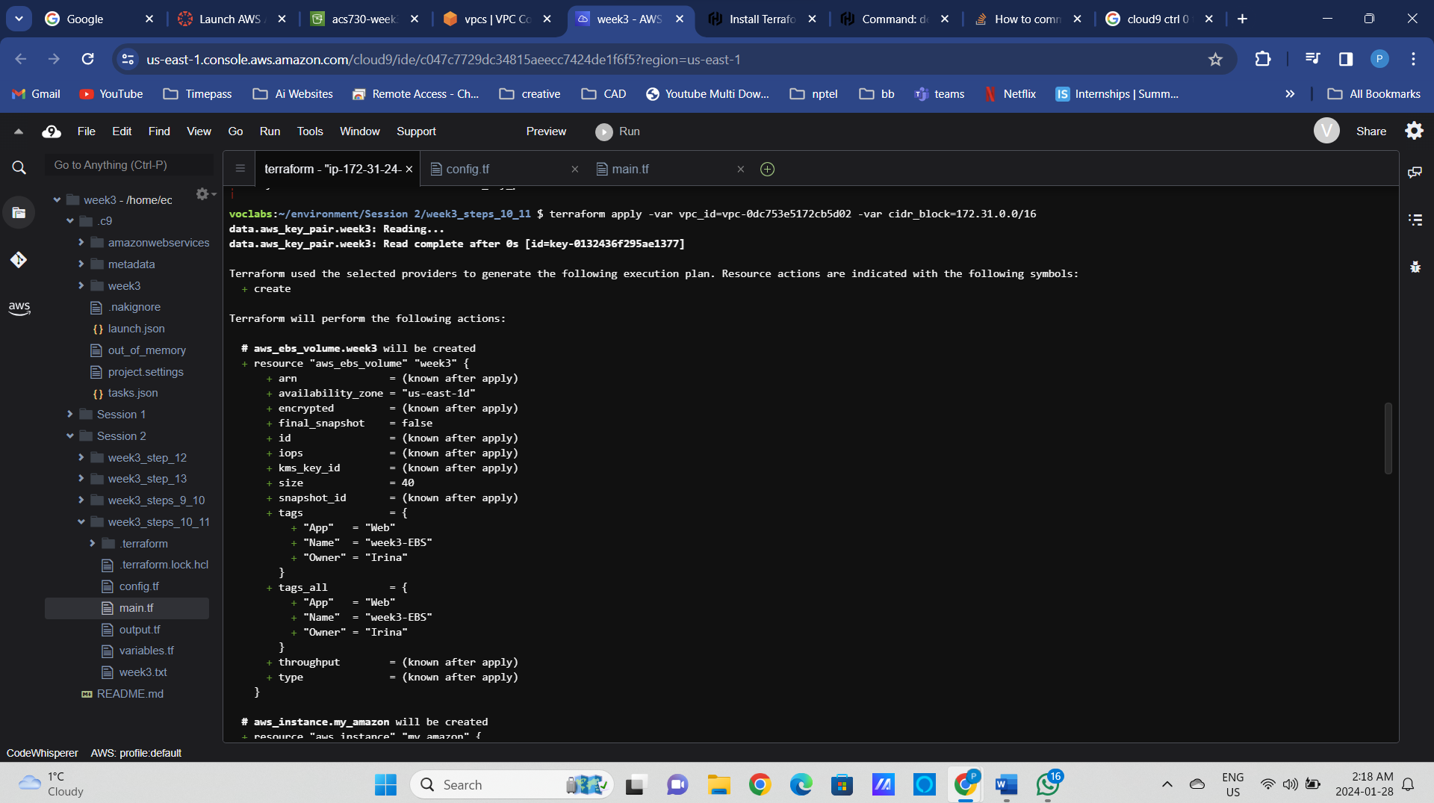

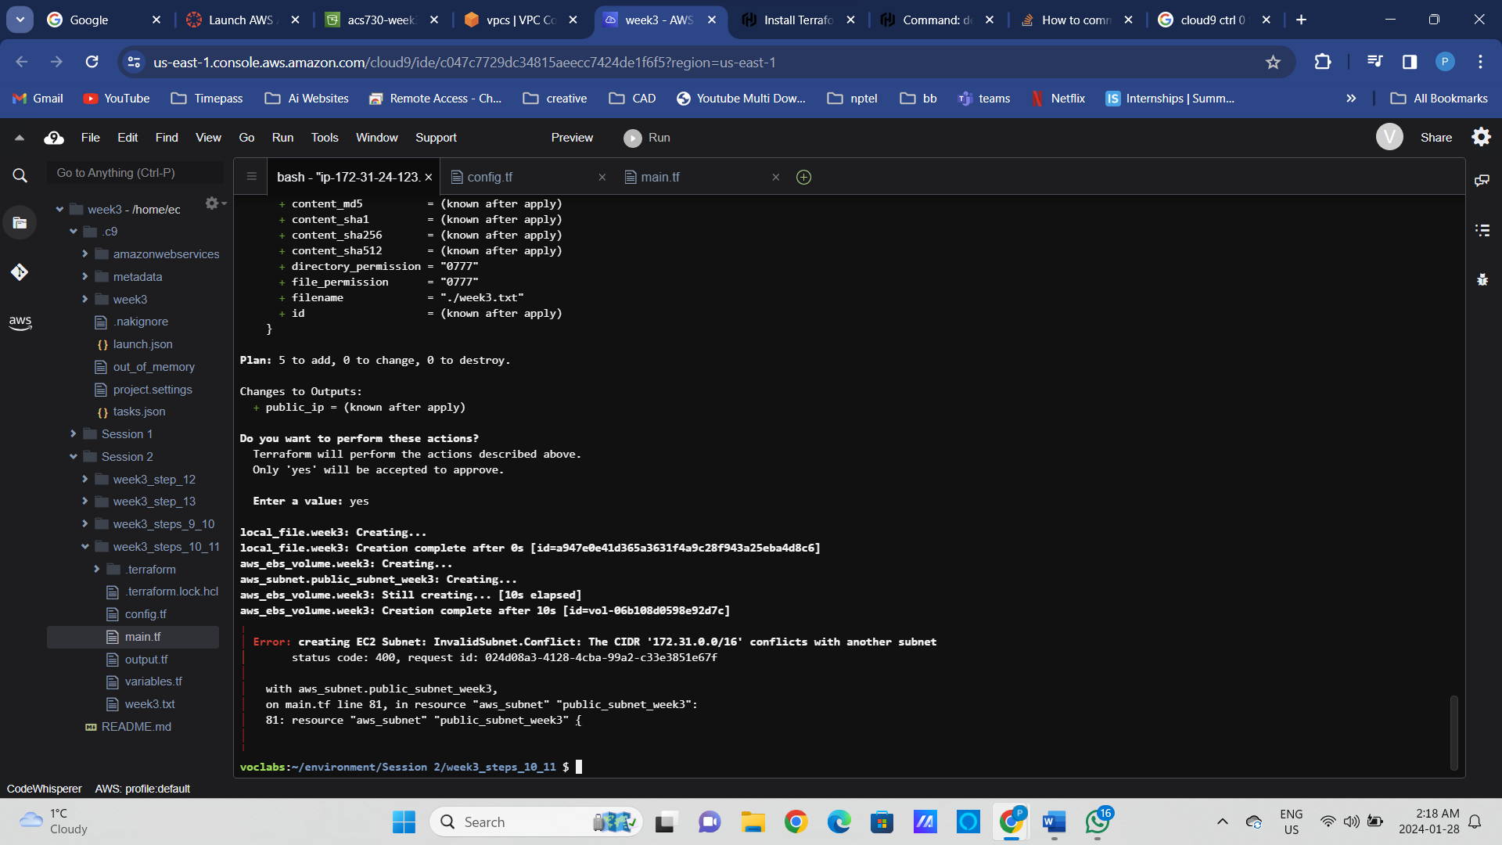

Now you can see the terraform state

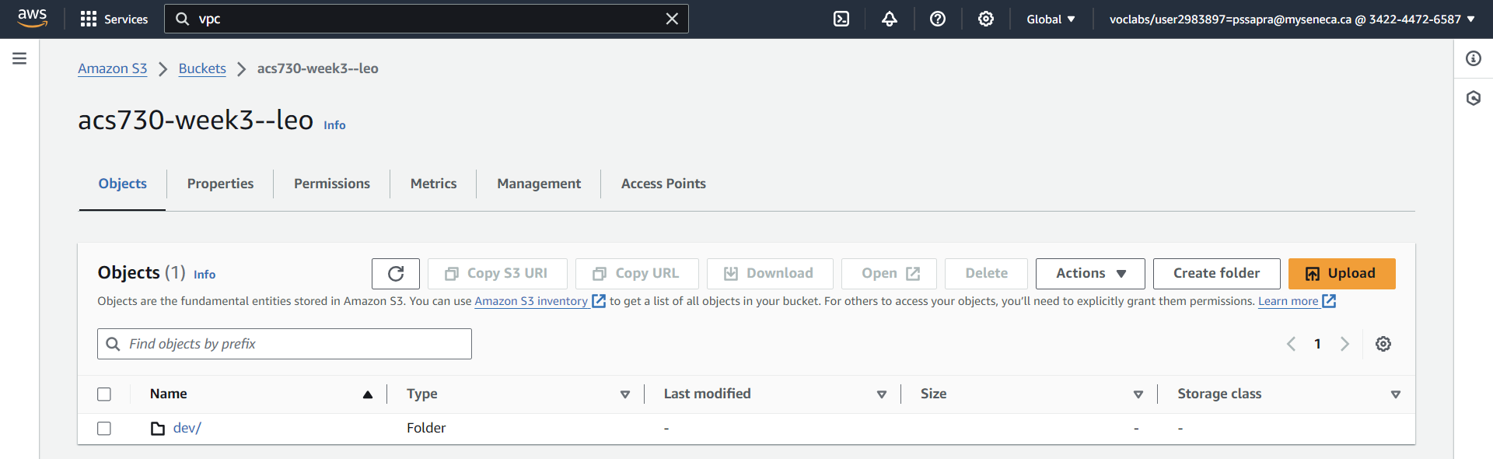

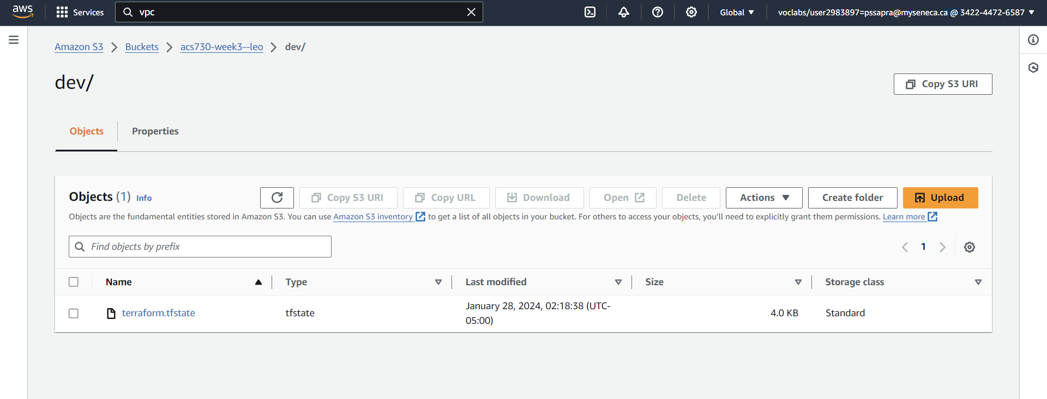

Create output variables for the instance id and subnet id in the output.tf file

* Run “terraform plan”, identify changes. Will the instance get redeployed?
* Add public IP association
* Re-deploy the changes with “terraform apply”.
* Print out the variables with the “terraform output” command

### Terraform output

* Destroy all the infrastructure with “terraform destroy”.

### Step12: Splitting the deployment into phases and working with the remote Terraform state

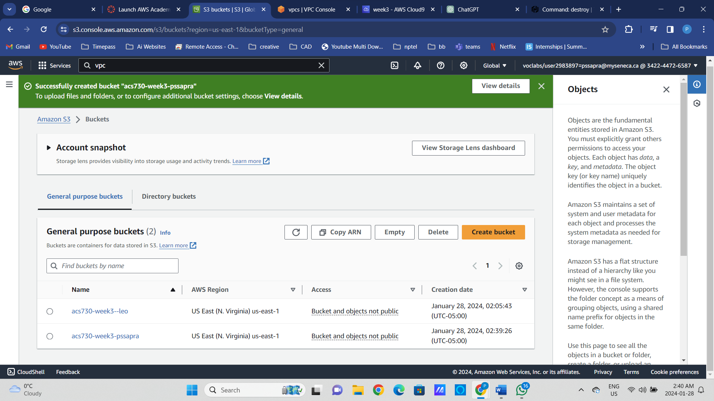

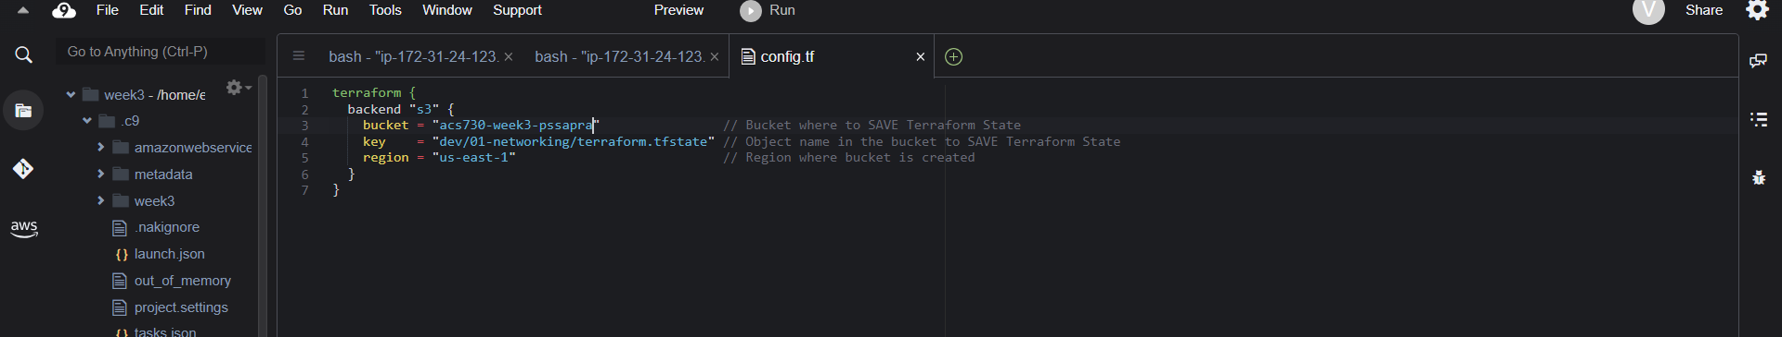

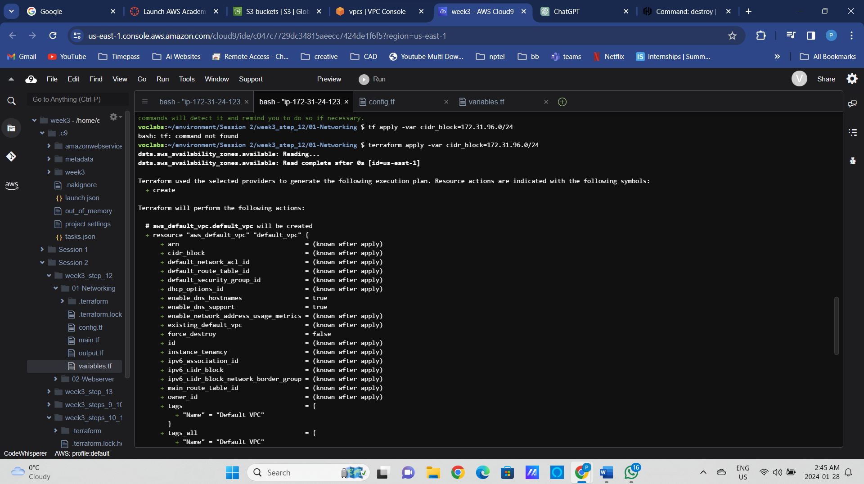

Webserver Step 12  
terraform apply -var cidr_block=172.31.100.0/26

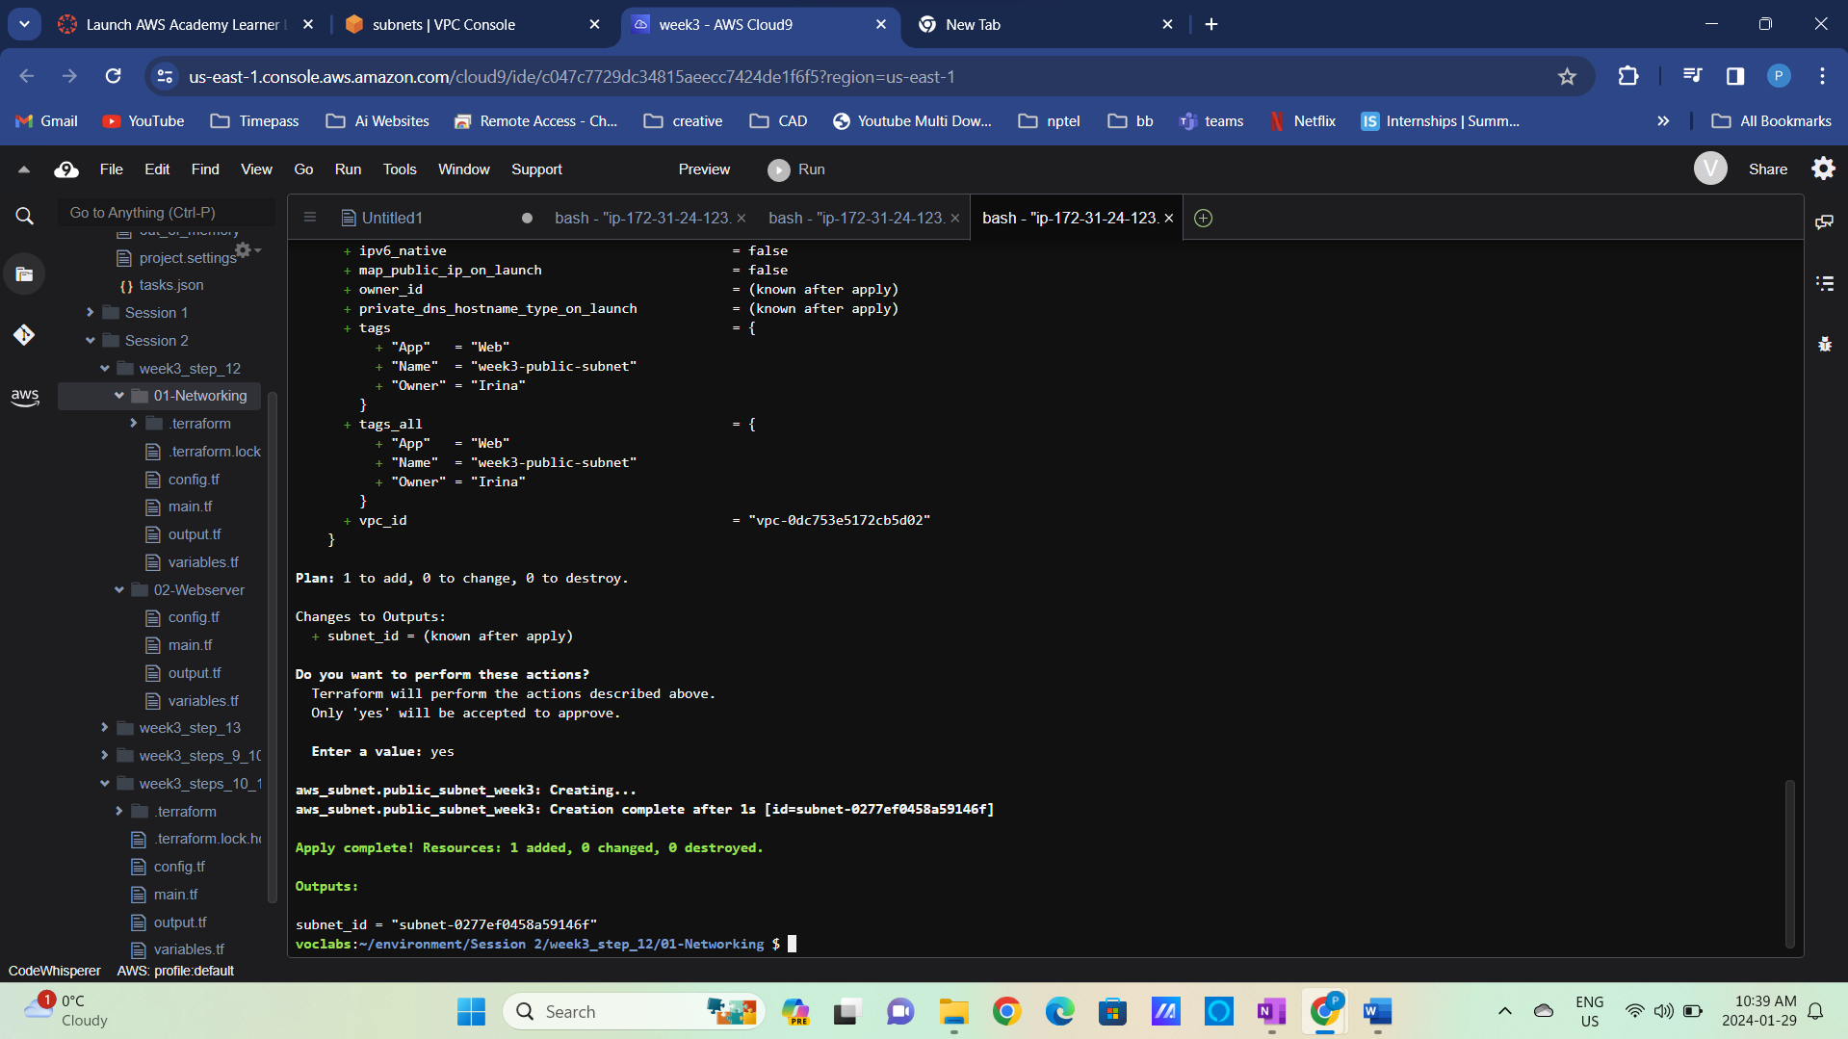

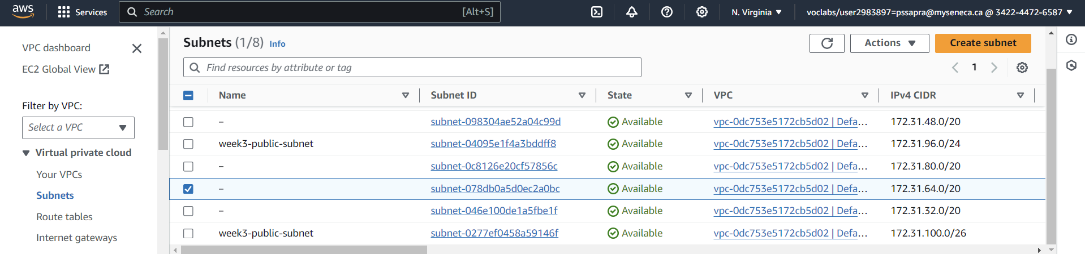

### Step13: Creating multiple resources of the same type – provisioning subnets in different availability zones

